Brief Write-up for

LIGHT WEIGHT FIRE PROTECTIVE SUIT

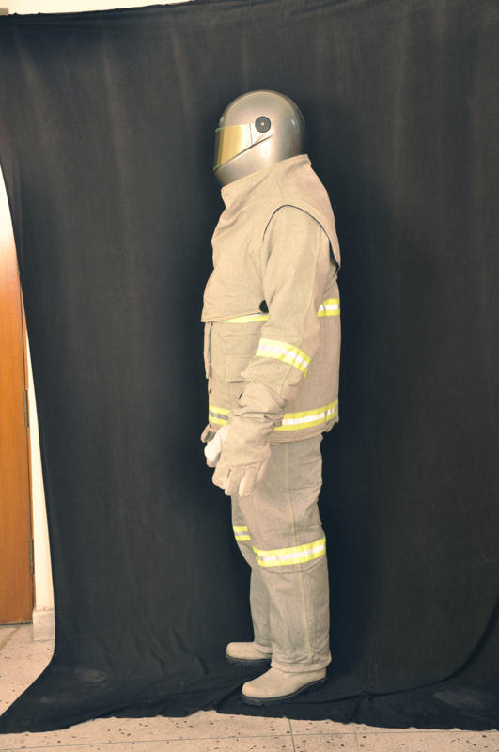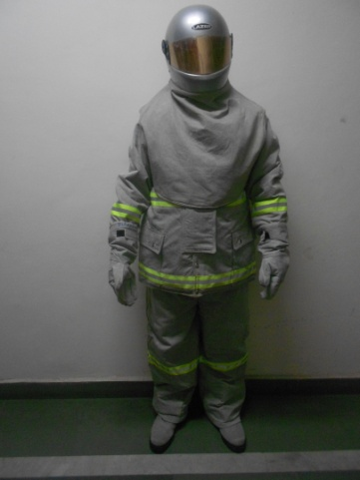
Light weight fire proximity suit
Light weight fire approach suit

DESCRIPTION:

Light weight fire approach suit and fire proximity suit are multi-layered suits used for fire-fighting & rescue operations. Light weight fire approach suit consists of three layers made up of high performance blended fibres:
- Outermost layer : Blended woven fabric(Indian Patent no-279558)
- Moisture barrier : Coated blended fabric
- Innermost layer : Fire Retardant cotton fabric

The weight of complete fire approach and proximity suits is approx 6.4 kg and 7.2 kg respectively. Both the suits have five components viz; Jacket with sleeves for protection of the torso portion including the arm but excluding the hands, Trousers for protection of legs excluding the feet, a pair of Gloves, a pair of Boots, Hood incorporating helmet and visor.

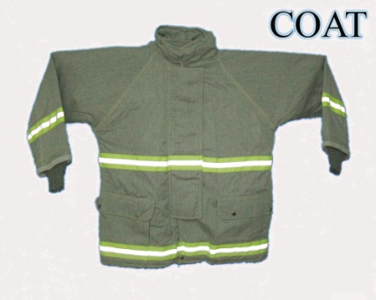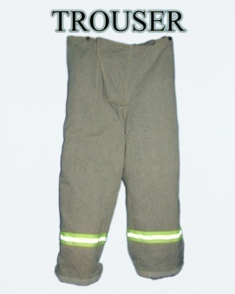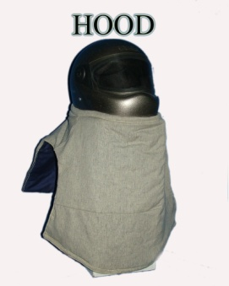

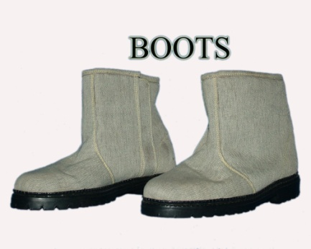
COMPONENTS OF LIGHT WEIGHT FIRE SUITS

Salient features:
- 30% lighter in totality over the existing aluminised suit.

- Light weight fire approach suit withstands for 10 minutes against the exposure of fire source of 50 liters aviation turbine fuel at 5 meter distance during live fire test trial while fire proximity suit withstands for 260 seconds at 3 meter distance during the same live fire test trial.
- Excellent maneuverability and freedom of movement to the fireman.

- Meets the performance requirements of NFPA 1971 and JSQR 8415-007 except breathability in moisture barrier fabric.

Possible Application Areas:
These suits can be used in fire fighting applications in Army, Air force & Navy, civil fire services, oil rig platforms & oil depot, ONGC, steel, plastic & chemical industries etc.

