Laser Guided Bomb Kit Tester (LGBKT)

LASTEC has developed a test system for performing serviceability checks of the seeker heads of Laser Guided Bombs like Griffin Kit LGBs and Elbit Lizard LGBs. The test system has a programmable laser source emitting a PULSED collimated beam to characterize LGB seekers.
In any LGB delivery operation the target to be destroyed is illuminated by high energy laser pulses, coded in terms of Pulse Repetition Frequency (PRF) code. The scattered laser pulses are sensed by the LGB seeker head, which aligns the LGB towards the target once the PRF code fed to the electronics of LGB gets matched with the PRF code of scattered laser radiation. This is the basic working principle of LGB delivery operation.
The developed Laser Guided Bomb Kit Tester (LGBKT) is a source of Laser radiation that simulates the laser pulses of Laser Target Designator, scattered from main target, in terms of PRF code and Power Density as seen by the Seeker head of LGB under test. The ‘lock-on’ checks on LGB are performed as an end to end check to confirm the serviceability of seeker head and LGB guidance unit in loop with the Aircraft avionics system. It is a standalone gadget with own rechargeable battery pack

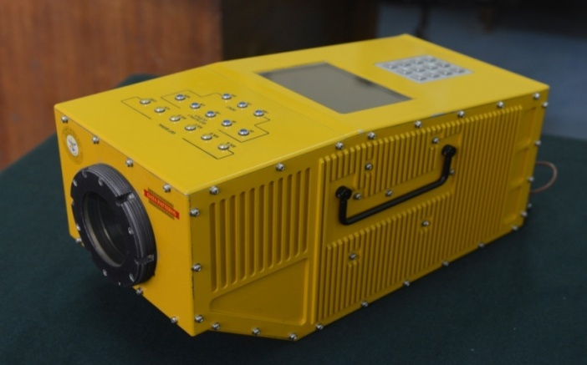
reflection from target from 500m, 5km, 10km
and at maximum range of 15km.

Photograph of developed System

The System is environmentally qualified and CEMILAC certified and has been extensively demonstrated to several potential users like Hindustan Aeronautical Limited (HAL) and Indian Air Force. Various agencies viz. Aeronautical Development Agency (ADA), Bangalore and Hindustan Aeronautical Ltd. (HAL), Bangalore have shown keen interest in this system. Two numbers of CEMILAC certified test systems have already been delivered to ADA, Bangalore for testing of Griffin Kit LGBs on board LCA.

