SELF PROPELLED MUNITION BURIER (SPMB)

Research & Development Establishment (Engineers), Pune, a premier laboratory under Defence R&D Organisation invites Expressions of Interest (EOI) from Indian industries having sufficient experience, expertise and willing to undertake production work of “Self Propelled Munition Burier” hereafter called as ‘system’. The industry should be technically & financially competent to manufacture and supply the ‘system’ with requisite quality standards.

BRIEF DESCRIPTION:
Munition laying is an important activity for Armed forces by deploying Munitions underground (in case of land Munitions) used as deterrent and delaying tactics for advancement of infantry, tanks & armored vehicles of enemy.
To create an anti-tank Munition field, R&DE(E), Pune, has developed mechanical Munition layer viz. Self Propelled Munition Burier (SPMB). This semi-automatic equipment is designed to store, dispense and lay four different types of anti-tank Munitions. The system is equipped with Munition locating system to record the location of buried Munitions with high accuracy, in order to recover the same. This equipment is capable of storing adequate nos of A/T Munitions, laying the same variable rate & depth. The “system” is based on TATRA 8x8 HMV and designed to operate in plains, semi desert and desert terrain available at Indian borders. The “system” stores the Munitions, lay the Munitions at desired depth and spacing, as well as records the location of buried Munitions. Except dispensing and arming of Munitions, all other operations are automated.
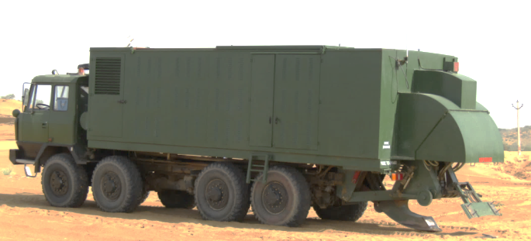

Picture : Self Propelled Munition Burier (SPMB)
TECHNICAL DETAILS & SALIENT FEATURES:
Self-Propelled Munition Burier (SPMB) is built on TATRA 8x8 HMV chassis. It consists of mechanical, electrical, electronic & hydraulic sub-systems.
The sub-system/ technology used in SPMB is appended below:
- Prime Mover: Tatra 8x8 HMV
- Mechanical System (Munition storage containers, Burying system, Platform and canopy etc.)
- Hydraulic System (Pump, linear actuators, reservoir, cooling system, valve bank etc.)
- Electronic Control system and Electrical system (Controller, Sensors, cable harness, battery bank, electrical motor, power distribution unit, alternator for electrical power etc.)
- Auxiliary Power Unit(APU): On-board auxiliary power for hydraulic and electrical operations.
- DGPS/GIS: Dedicated DGPS and GIS system for navigation and recording of Munition data, hand held DGPS for locating the buried Munitions.

The salient features of SPMB are appended below:
- Capable to lay four types of anti-tank Munitions
- Navigation: On Board GPS/GIS
- Replenishment of Munitions: Loading/unloading of Munition containers with the help of crane/ Manual replenishment of Munitions
- Power Pack: Dedicated Auxiliary Power Unit (APU), Independent of Carrier Vehicle
- Communication: Wired voice communication between driver and commander.
- Under Water Laying
- Can operate in a temperature range of 0-45°C.

Interested industries may respond along with their company profile, financial & technical capabilities etc. as per the following format :

(a) Memorandum and Articles of Association (Should be incorporated as per Indian
Companies Act, 1956)
(b) Certificates of registration as a manufacturing unit, if any. (c) Balance Sheet for the preceding three years.
(d) Income Tax returns for the preceding three year period
(e) Details of shareholding/ownership pattern especially foreign partners/ shareholders, foreign employees, directors, etc. The company must adhere to the prevailing Govt. of India policies and regulations on Foreign Direct Investment (FDI).
(f) Annual budget for R&D during last three years.
(g) Numbers and details of IPR or patents etc held by the company. (h) Number of technically or professionally qualified personnel.
(i) Record of past performance (e.g Supply orders executed against Ministry of
Defence orders, public sectors and paramilitary forces, if any.
(j) Availability of adequate infrastructure (List of machines and their production capacities) and technical expertise.
(k) List of Testing and Support equipments
(l) ISO/ ISI certification or any other certification
(m) Relevant clearances from the authorities/ ministries (if any)
(n) Capacity and capability to undertake developmental work and to accept attendant financial and commercial risks.
(o) Capacity/Capability to market the product through the marketing network, sales and service network, reliability to maintain confidentiality.

Eligible industries will be invited to sign Non-Disclosure Agreement with R&DE (Engrs) and for technical discussion, following which they shall be evaluated for giving Transfer of Technology (TOT) on non-exclusive basis. Criteria for choosing industry partner will include manufacturing capability, assurance on quality and capacity of production apart from other terms and conditions.

Interested industry may write to Director, R&DE(Engrs), Pune on the following address –

Director, R&DE(Engrs). DRDO, Min. of Defence, Alandi Road, Dighi,
Pune – 411015
They may also contact on phone – (020) 27044520, (020) 27044544
Email: director@rde.drdo.in , akupadhyay@rde.drdo.in, akgupta@rde.drdo.in
Or
Director, DIITM,DRDO HQ,
Min. of Defence, DRDO Bhawan, Room No. 447, B Block,
Rajaji Marg, New Delhi - 110011
Phone – 011 23013209
Email: tot@hqr.drdo.in

