120mm High Explosive Squash Head Mark-I
Description of the technology:
120mm High Explosive Squash Head (HESH) Mark-I is a single piece ammunition with combustible cartridge case for MBT Arjun. On impact with the target, the extremely reliable base fuze initiates the high explosive composition contained in the shell with an optimum delay. The high strength stress waves travel into the target till the other end, where as a result of change in impedance, travel back into the target with a reversal of phase. This sequence continues until at a point, the strength of stress wave exceeds the tensile strength of the target. A heavy chunk of target material (up to 4 to 10 kg) separates out from the other end of the target and flies with a velocity of the order of 100 m/s. This chunk of material is called ‘scab’. This is sufficient to permanently damage the essentials of tank and harm the tank crew to achieve ‘Total Kill’.
As a secondary effect, the jolt experienced by the tank and tank crew is extremely severe to render the weapon neutralized. The fragmentation achieved by the shell is more lethal compared to similar High Explosive shells in use. The ammunition is extremely reliable and safe to use. The consistency and accuracy of the ammunition are excellent and meet the stringent acceptance criteria of the Indian Army. Due to its low muzzle velocity, it causes minimum barrel wear, thus enhancing the barrel life manifold.
The ammunition utilises indigenous Double Base Propellant with Resin base combustible cartridge case. The shelf life of ammunition has been established to be minimum 10 years.
Application Areas:
It is an anti-tank, anti-material ammunition, which uses Chemical Energy to defeat the tank armour and fortifications. This ammunition can also be effectively used as a general purpose ammunition against troop concentrations in open, bunkers, ammunition or fuel dumps, vehicle convoys etc.
Certifications and test results:
The ammunition is in service for past 10 years. More than 15,000 rounds have been produced and more than 10,000 rounds have been fired successfully.

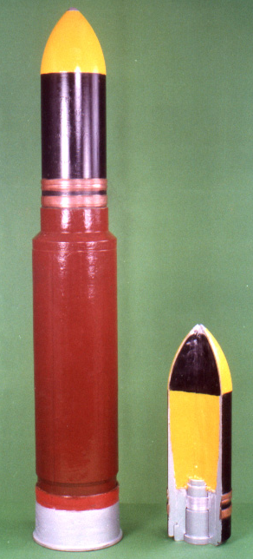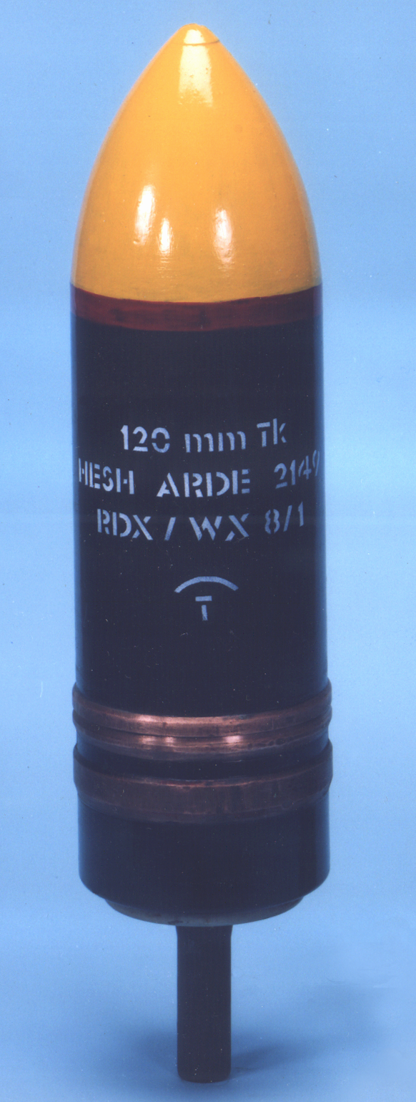
Round 120mm HESH with Shell and base Fuze HESH shell

