Description of Technology- MR Fluid
There are several situations if a material can effectively interface between mechanical and electric (electronic) components, the capability of the device can be improved several fold. For example in the case of automobile vibration dampers / suspensions or hydraulic coupling devices the performance of the device is largely depend on the viscosity of the working fluid employed. Normally, the fluid is optimized with a viscosity and cannot be changed in the field. If we have a fluid whose viscosity can be tuned to any desired value, device performance can also be tuned as situation demands in the field.
For this purpose, NPOL, Kochi have a synthesised a fluid and this fluid exhibits characteristic change in viscosity, when subjected to permanent or temporary magnetic field. The changes are such that a reversible transformation from liquid state to near solid state occurs within a fraction of second in the presence of a magnetic field. Depending on the magnetic field strength, the fluid can flow like water, ooze like honey or solidify into a gel all in matter of milliseconds. This property can be utilized to design a smart anti-vibration mount / shock absorbers /damper which can be programmed to provide variable damping ( shock absorption) and vibration isolation. The following are the potential applications areas:-
(a) Automotive applications: Engine mounts, shock absorber suspension, seat dampers, clutches, brakes, hydraulic devices
(b) Rapid prototyping : Reconfigurable mould
(c ) Bio medical : Smart prosthetics
(d) Aero space: Smart Landing gear for air-crafts
(e) Space applications : Servo valve, astronautical mirror polishing,
(f) Vibration Damping : Seismic Damper, Vibration Damper for machineries such as washing machine, Mitigation of vibration due to wind loading
in bridges
(g) Exercise machine: Treadmill, exercise bicycle

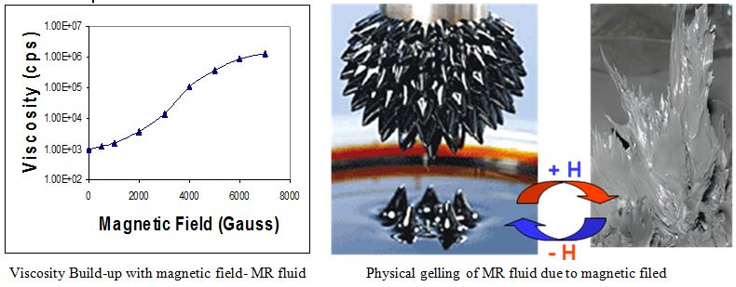
PATENT OBTAINED BY NPOL FOR THIS FLUID
Patent Name | Patent Number | Country
Magnetorheological fluid composition and a process for preparation thereof | 232363 | India
Magnetorheological fluid composition and a process for preparation thereof | 6,875,368 | USA
Magnetorheological fluid composition and a process for preparation thereof | EP 1344229 | France
Magnetorheological fluid composition and a process for preparation thereof | EP 1344229 | UK
Magnetorheological fluid composition and a process for preparation thereof | 4104978 | Japan

