|  |  |
| --- | --- |
| Version : 2.0 | Date: August 2023 |

Directorate General of Aeronautical Quality Assurance

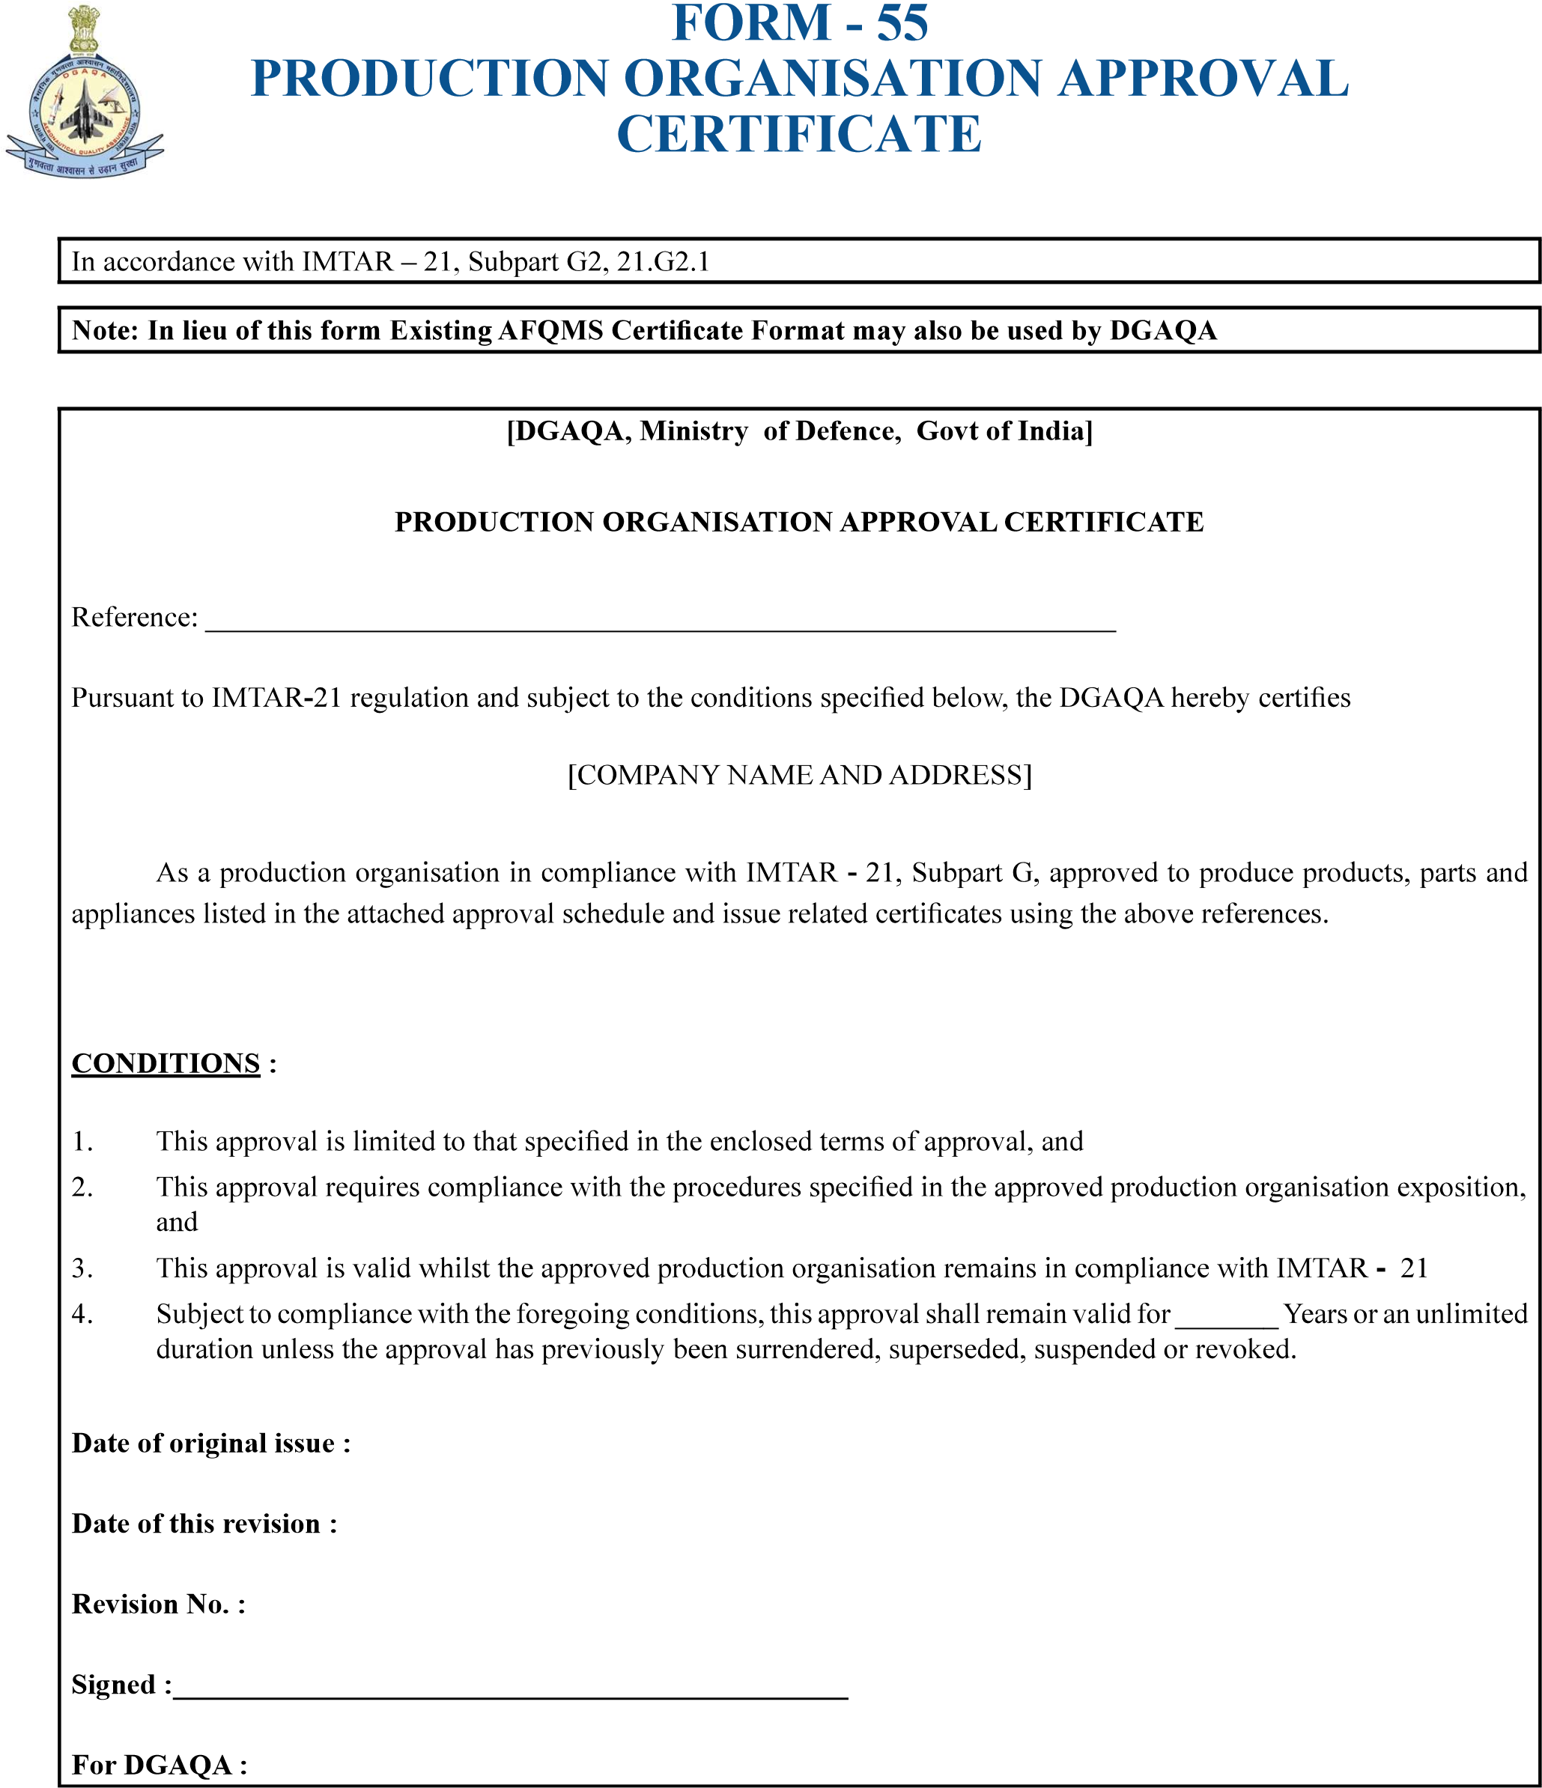

…………………………………………

………………………………

………………………….

……………………………..

………………………………………………………………………………………………………………

……………………………………………………………..

|  |  |
| --- | --- |
| Version : 2.0 | Date: August 2023 |

Directorate General of Aeronautical Quality Assurance

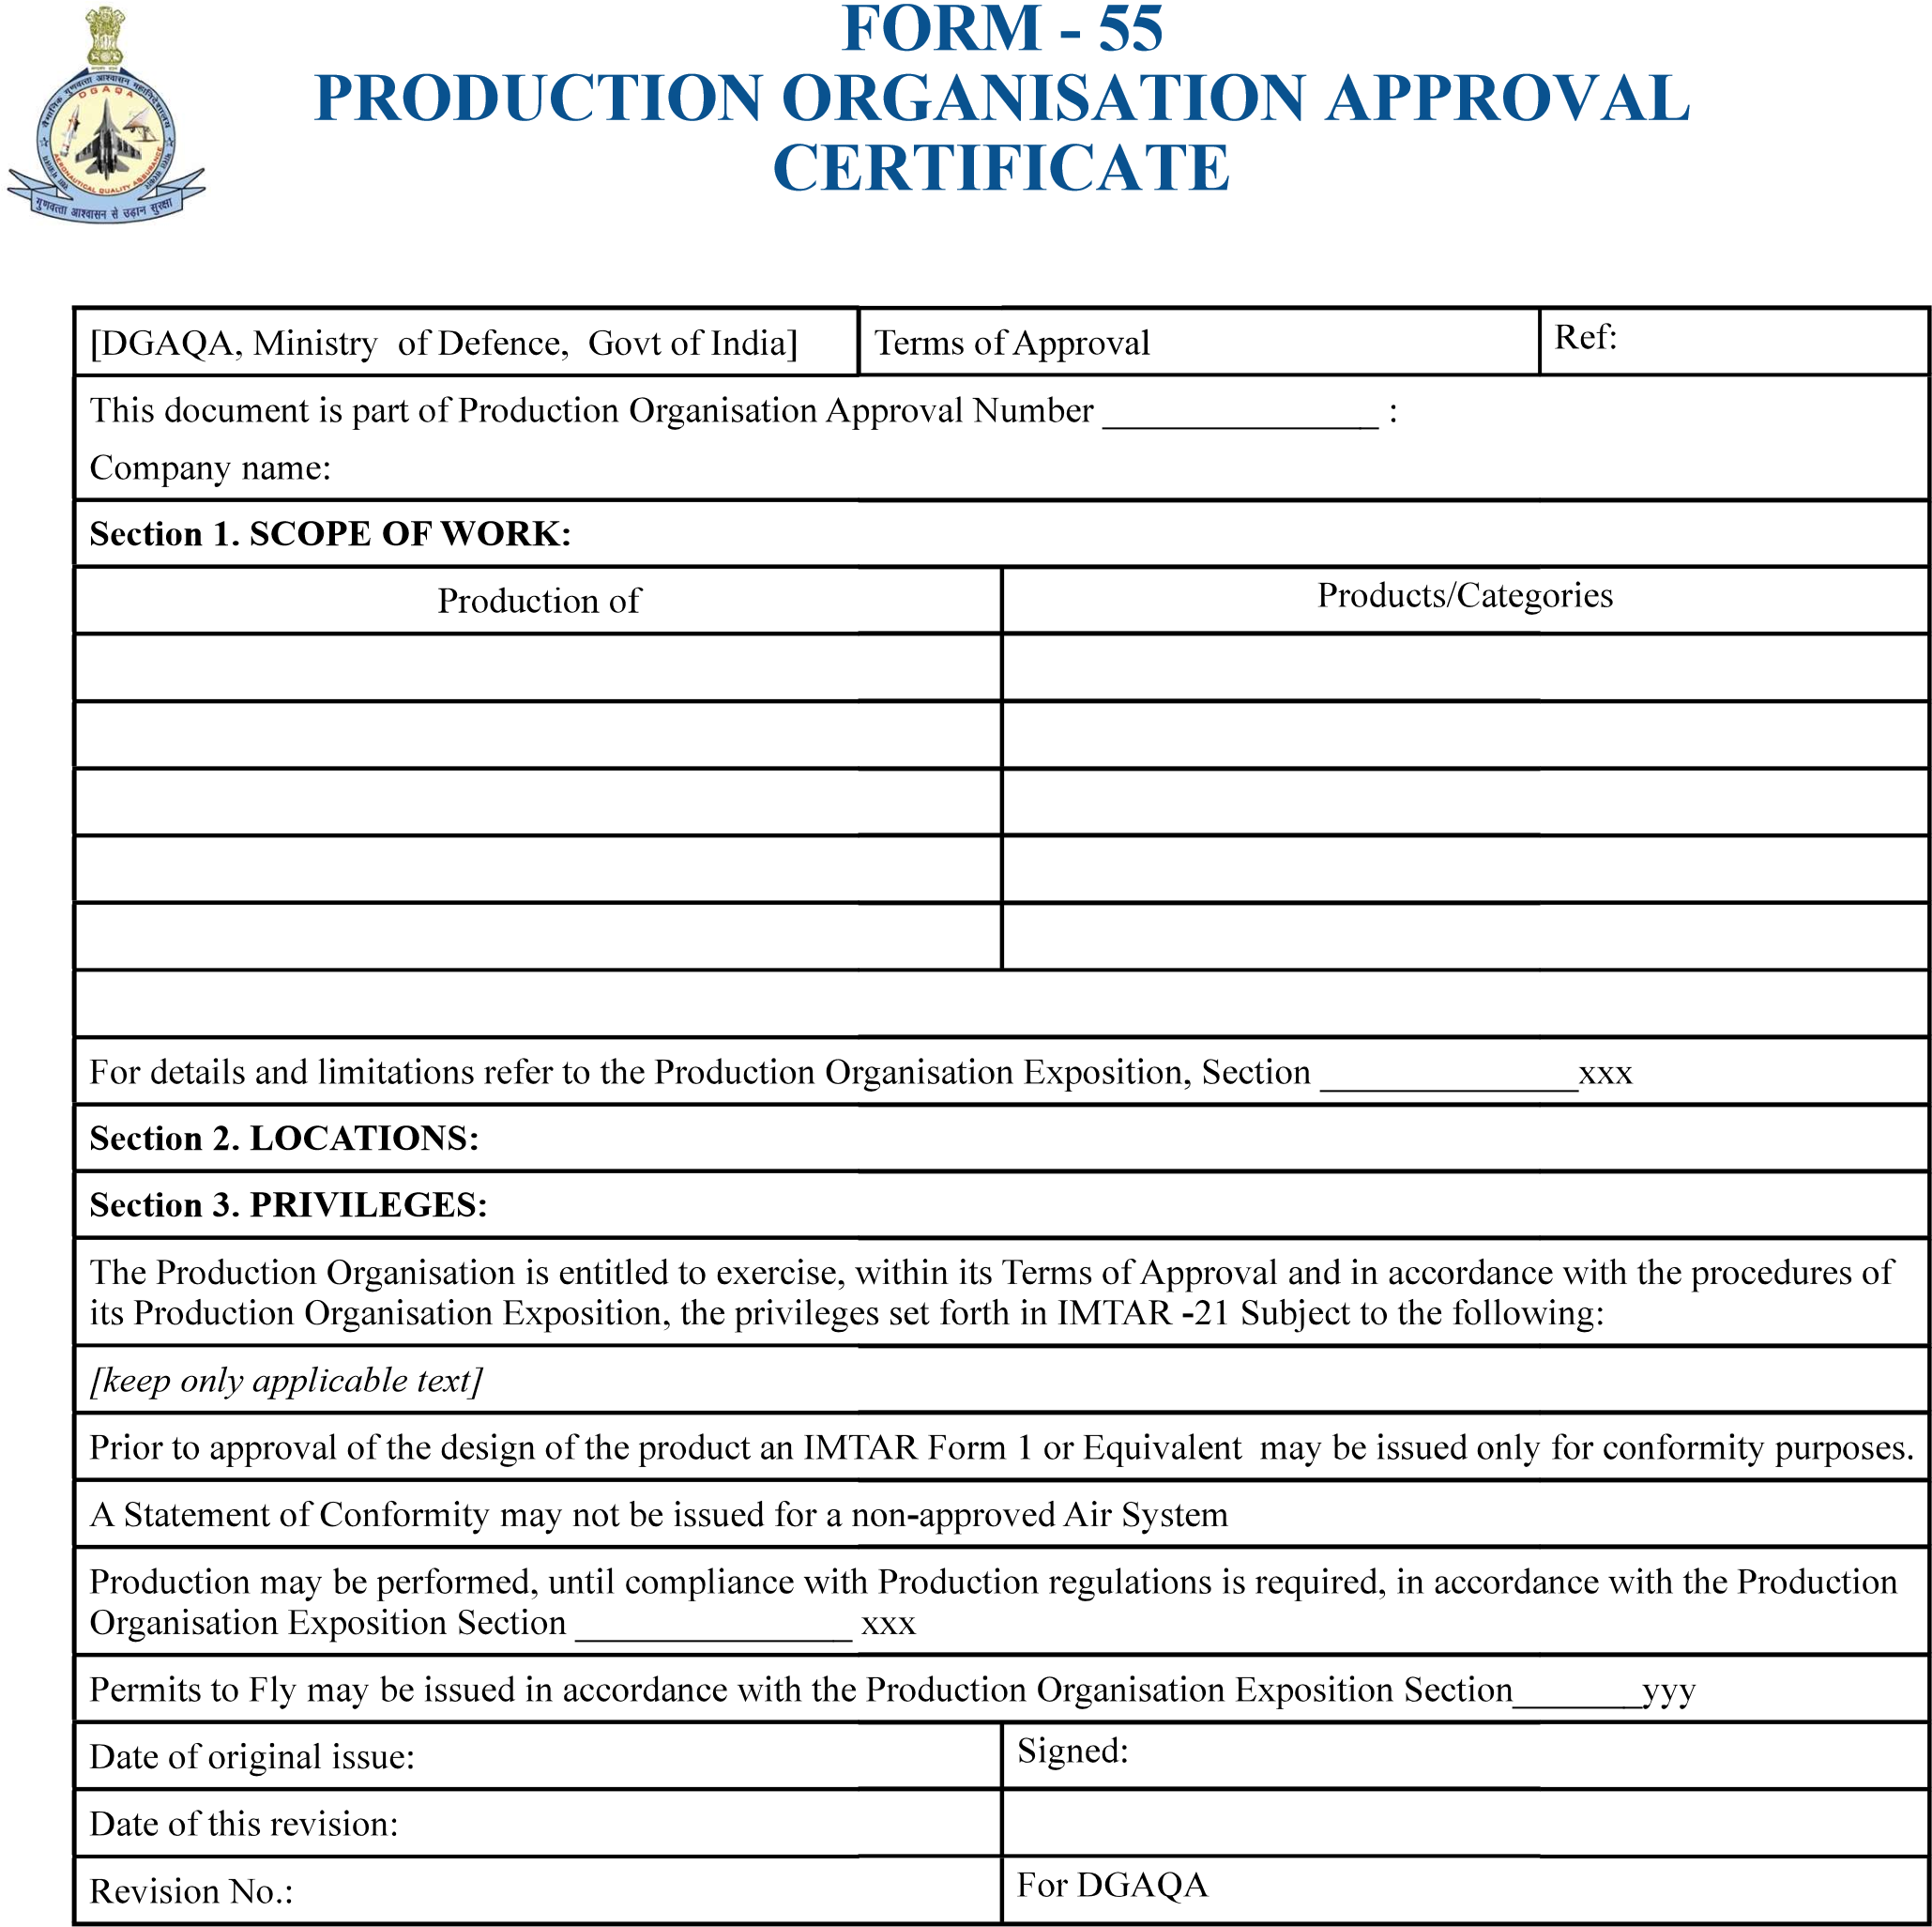

…………………………….

……XXX……

…………..

………………………………………………

…………