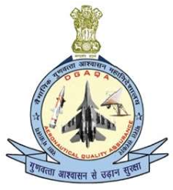 Directorate General of Aeronautical Quality Assurance

FORM - 51

APPLICATION FOR SIGNIFICANT

CHANGES OR VARIATION OF SCOPE AND TERMS OF PRODUCTION ORGANISATION APPROVAL

Note: This Form is made Optional / Not Mandatory

|  |  |  |
| --- | --- | --- |
|  | DIRECTORATE GENERAL OF AERONAUTICAL QUALITY  ASSURANCE (DGAQA)  GOVERNMENT OF INDIA, MINISTRY OF DEFENCE ‘H’ BLOCK, NEW DELHI-110011 | |
|  | Name and address of the Approval holder |  |
| 2. | Approval reference number |  |
| 3. | are requested |  |
|  |  | |
|  |  |  |
|  |  |  |
|  |  |  |
| 5. |  |  |
| 6. | nominee |  |
|  | …………………………. | ……………………………………………. |

 Directorate General of Aeronautical Quality Assurance

FORM - 51

APPLICATION FOR SIGNIFICANT

CHANGES OR VARIATION OF SCOPE AND TERMS

OF PRODUCTION ORGANISATION APPROVAL

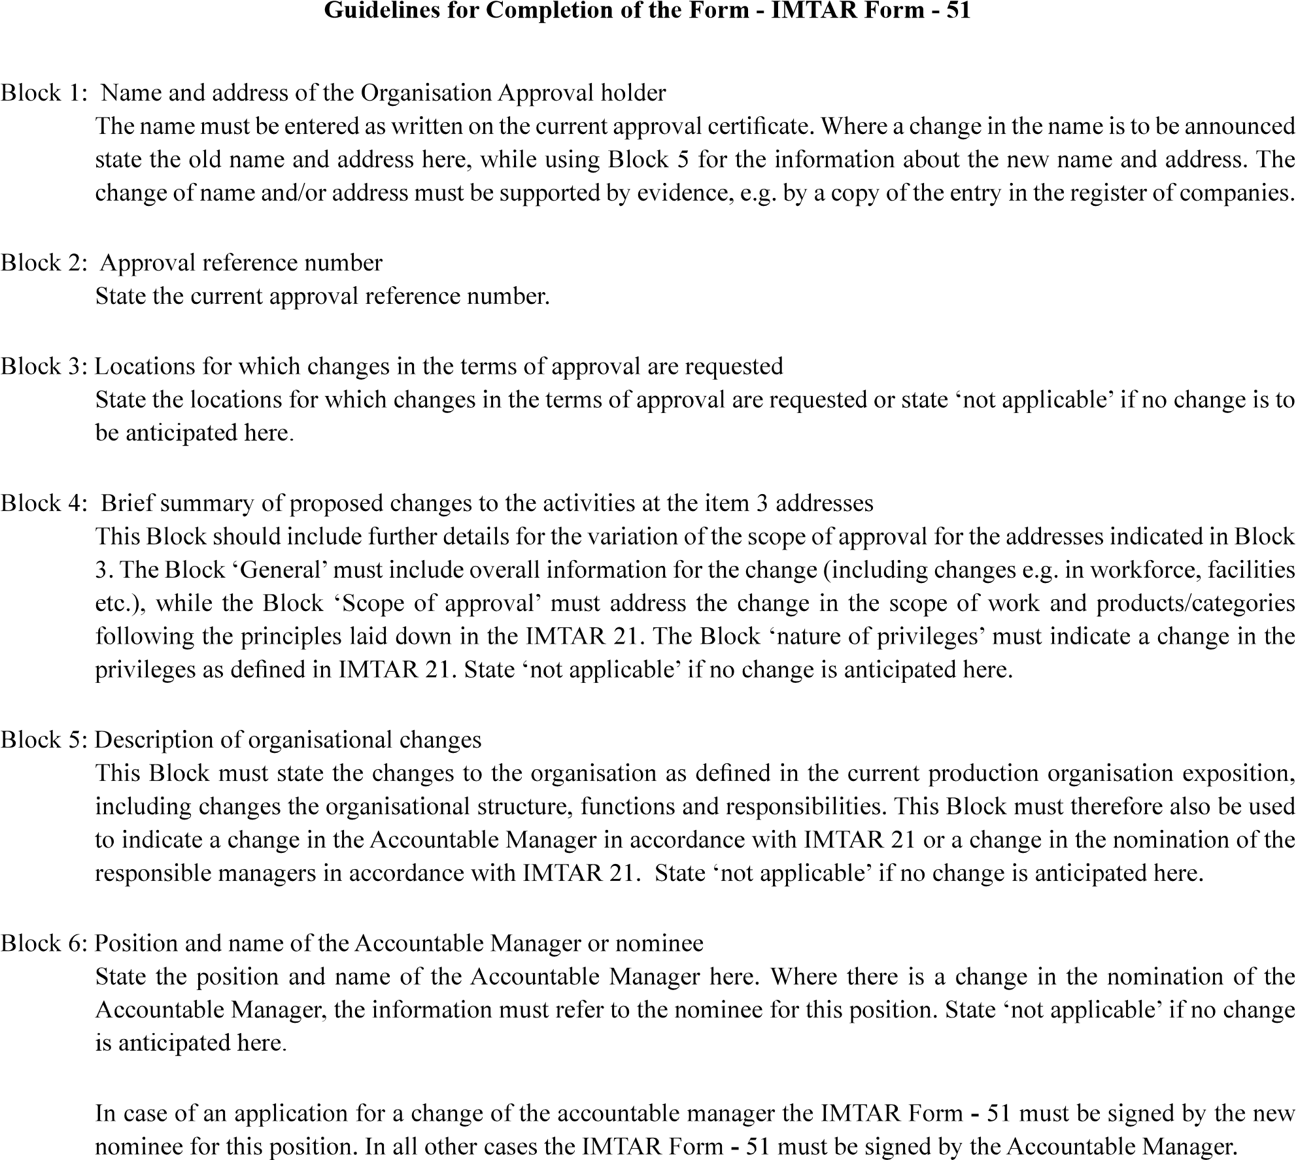

|  |  |
| --- | --- |
| Version : 2.0 | Date: August 2023 |

|  |  |
| --- | --- |
| Version : 2.0 | Date: August 2023 |