# FORM - 40A APPLICATION FOR CLEARANCE OF AIRBORNE STORES IMPORTED FROM FOREIGN COUNTRY

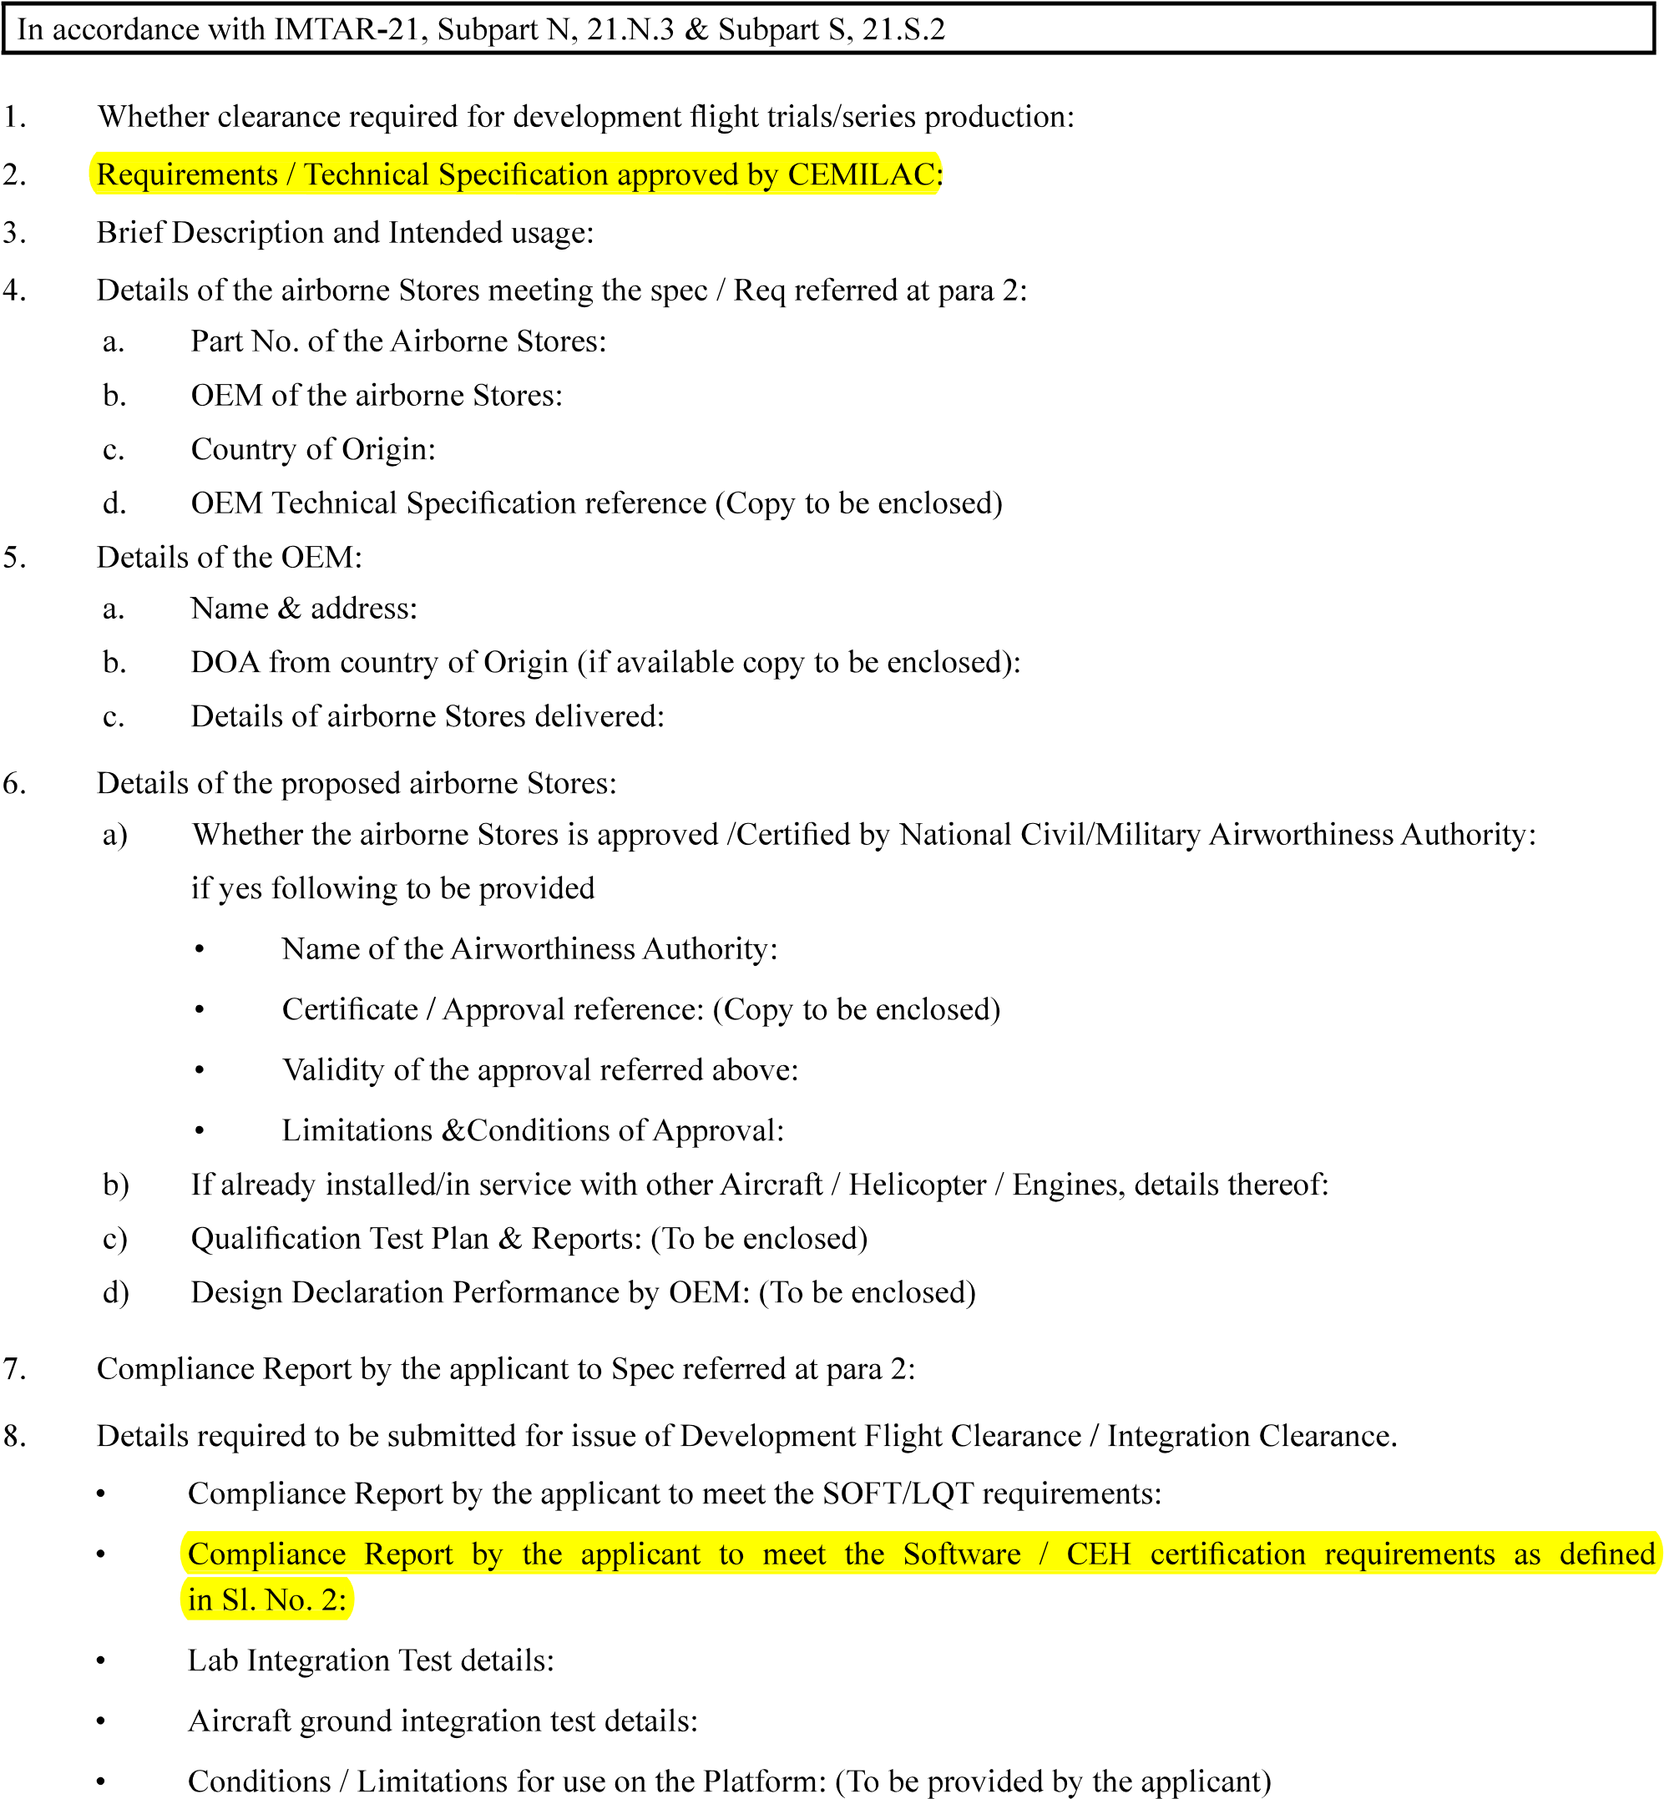

………………………………..

……………………………….

……………………………

…………………………….

……………………………………

……………………………………………………………..

…………………………………..

……………………………………

|  |  |
| --- | --- |
| Version : 2.0 | Date: August 2023 |

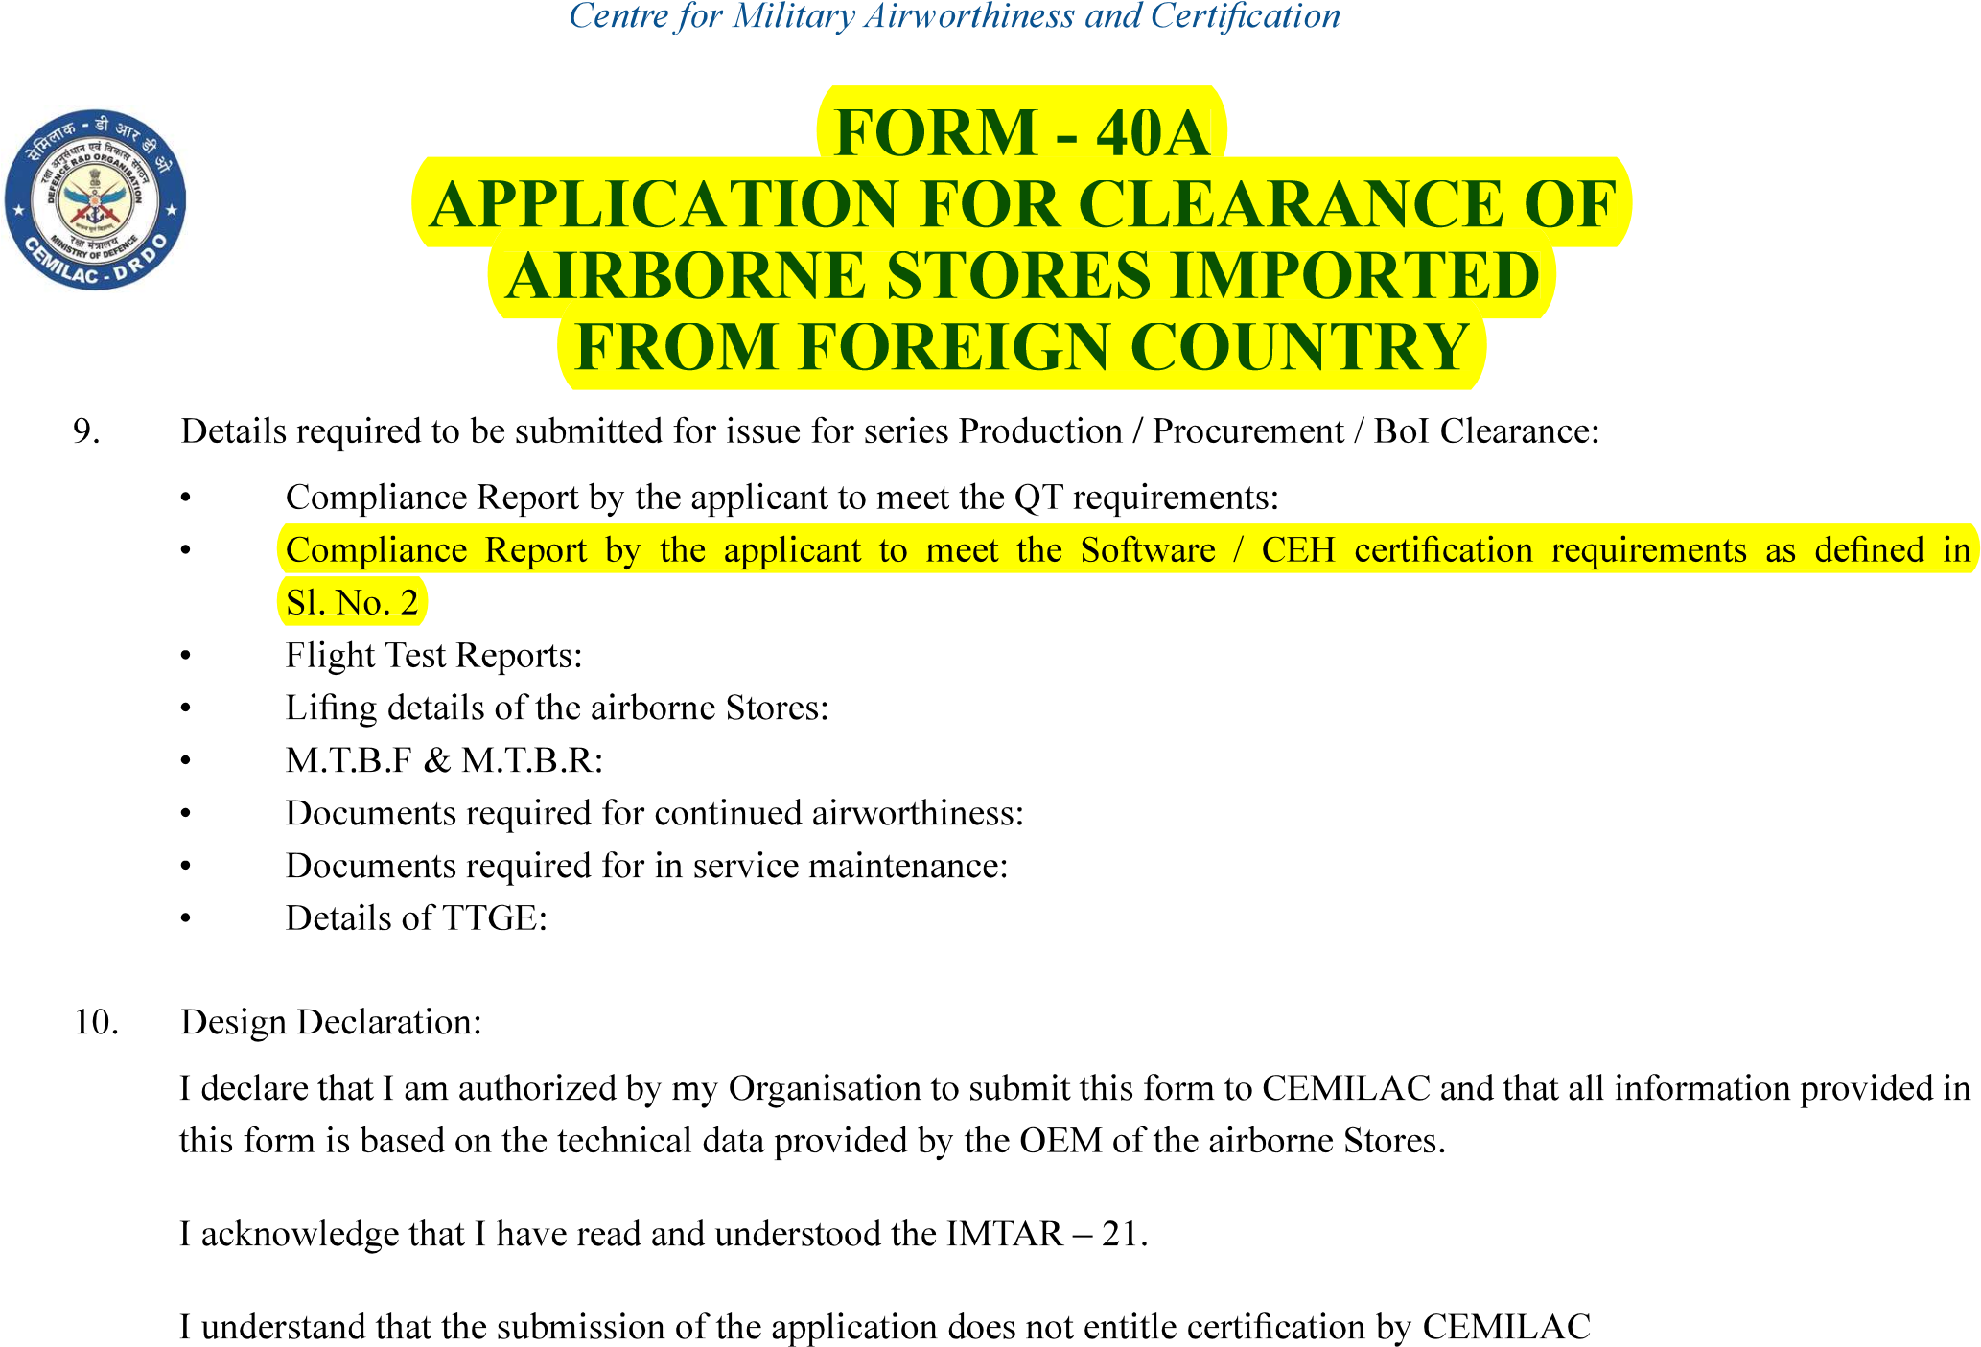

……………………

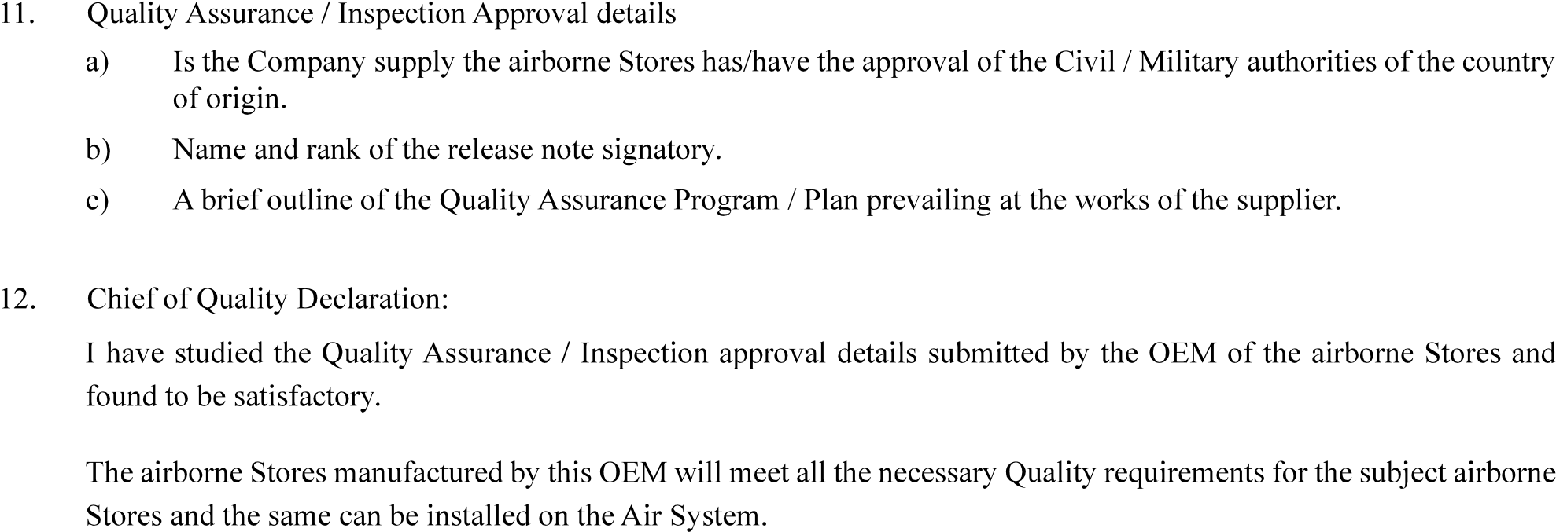

……………………….

…………………………………….

……………

Name

|  |  |
| --- | --- |
| Version : 2.0 | Date: August 2023 |