1. | Grantor’s Reference |  |  |  | Date:
2. | PC / TA / LoA / IMATSOA Details
2.1 | PC / TA / LoA /  IMTSOA Details | of Issue
 |  | Number
 |  | Nomenclature
 |  | TA issued under
 |  | Reference
3. Grantor’s (TA Holder) Information
3.1 Applicant Company Data
Name and Address |  | Applicant Number
 |  | PIN
3.2 Organisation Approval Details
DOA Details

4. | Receiver’s Information
4.1 | Address  communication
 |  | PIN

4.2 | DOA Details
5. | Transfer Details
5.1 | Reasons for Transfer
5.2 | Transfer Agreement
6. | 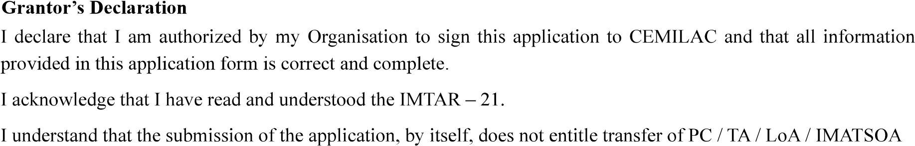
 |  |  | Name
7. | 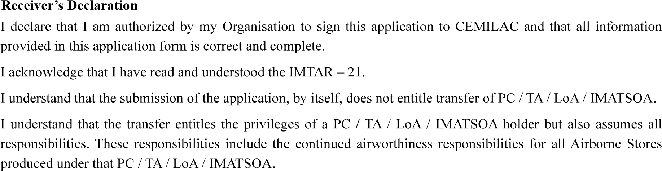
 |  |  | Name
Note: This application shall be forwarded to dealing RCMA / CEMILAC for further process.

Acknowledgement of Receipt of Application
1. | Applicant’s Reference
2. | Address
 |  | PIN
3. | Airborne Stores Title
……………………
in due course of time.
…………………………….

