1. | Grantor’s Reference |  |  |  |  | Date:
2. | MTC / RMTC Details
2.1 | RMTC / MTC  Details
3. Grantor’s (MTC Holder) Information
3.1 Applicant Company Data
Name and Address |  | Applicant Number
 |  | PIN
3.2 Organisation Approval Details
DOA Details

4. | Receiver’s Information
4.1 | Address  communication  to this
 |  | PIN
4.2 | DOA Details

5. | Transfer Details
5.1 | Reasons for Transfer
5.2 | Transfer Agreement
6. Grantor’s Declaration

 |  | Name
7. Receiver’s Declaration
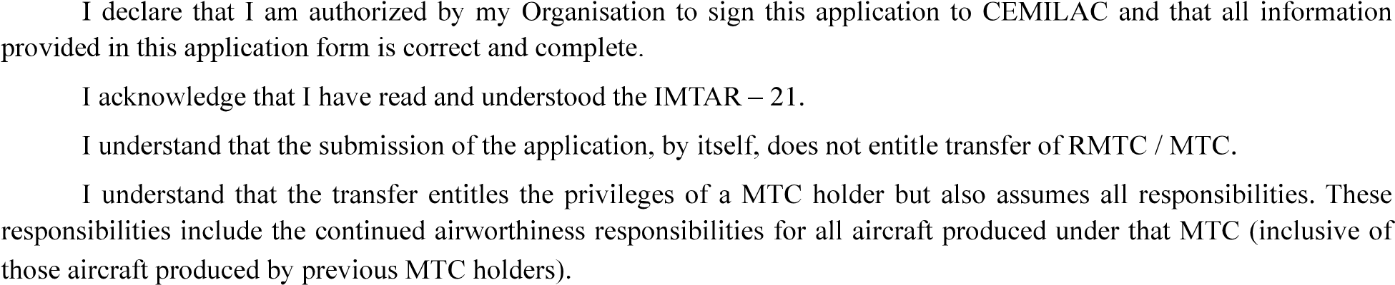
 |  | Name
Important Note: CEMILAC does not accept applications without signature. Please make sure that the application is

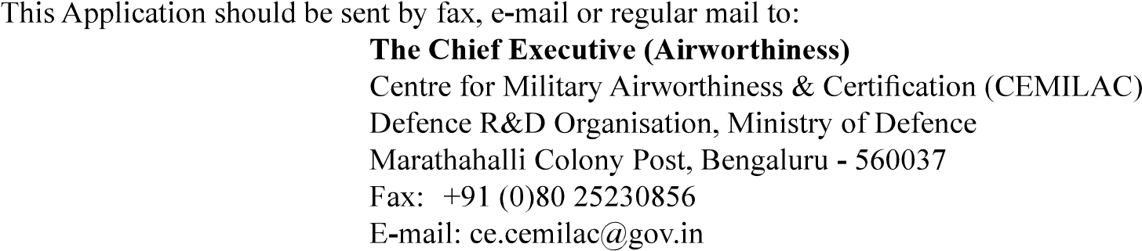

Acknowledgement of Receipt of Application

1. | Applicant’s Reference
2. | Address
 |  | PIN
3. | Air System Title
…………………...
in due course of time.
………………………………

