…………………………………………………

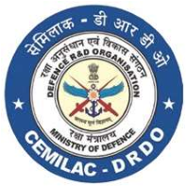

FORM -30D

APPLICATION FOR RENEWAL OF

RMTC/MTC FOR AIR SYSTEM

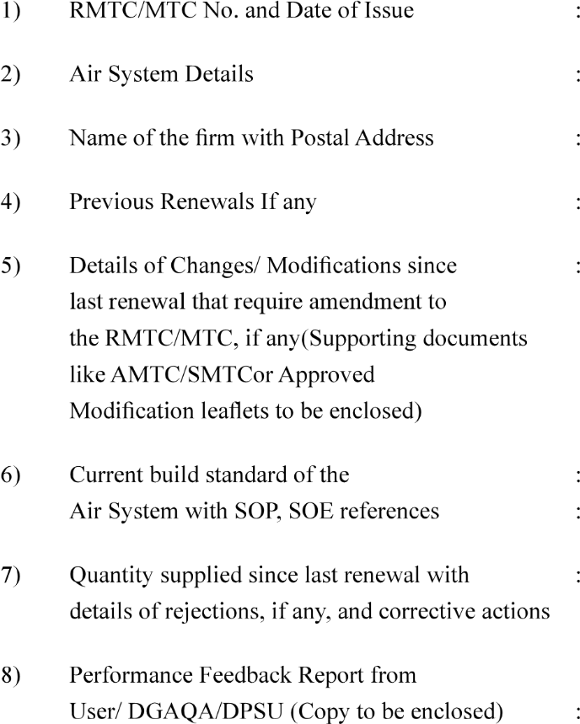

……………………………………….

……………………………….

………………………………………….

…………………………………………………

…………………………………….

…………………………………………………

…………………………………………..

…………………………………………………

(Signature of Head of the Design)

|  |  |
| --- | --- |
| Version : 2.0 | Date: August 2023 |