FORM - 30C

TYPE RECORD FOR AIR SYSTEM

|  |  |  |  |  |  |  |
| --- | --- | --- | --- | --- | --- | --- |
| Sl. No. | |  | Contents of Type Record | | Details, Reference | Record (as Appendix-A onwards with Page numbers) |
|  | |  |  | |  |  |
| 2 | | a | Nomenclature | |  |  |
|  | | b | Part Number | |  |  |
| 3 | |  |  | |  |  |
|  | |  |  | |  |  |
|  | level. | |  |  |
|  |  | |  |  |
| c | Process document | |  |  |
| 5 | |  |  | |  |  |
| 6 | |  |  | |  |  |
| 7 | |  |  | |  |  |
| 8 | |  |  | |  |  |
| 9 | |  |  | |  |  |
|  | |  |  | |  |  |
|  | |  |  | |  |  |
|  | |  |  | |  |  |
|  | |  |  | |  |  |
| Version : 2.0 | | | Date: August 2023 | | |

66

FORM - 30C

TYPE RECORD FOR AIR SYSTEM

|  |  |  |  |
| --- | --- | --- | --- |
| Sl. No. | Contents of Type Record | Details, Reference | Record (as Appendix-A onwards with Page numbers) |
|  | shall be indicated. |  |  |
|  |  |  |  |
|  |  |  |  |
|  | applicable |  |  |
|  |  |  |  |
|  |  |  |  |

Signature of Head of Design

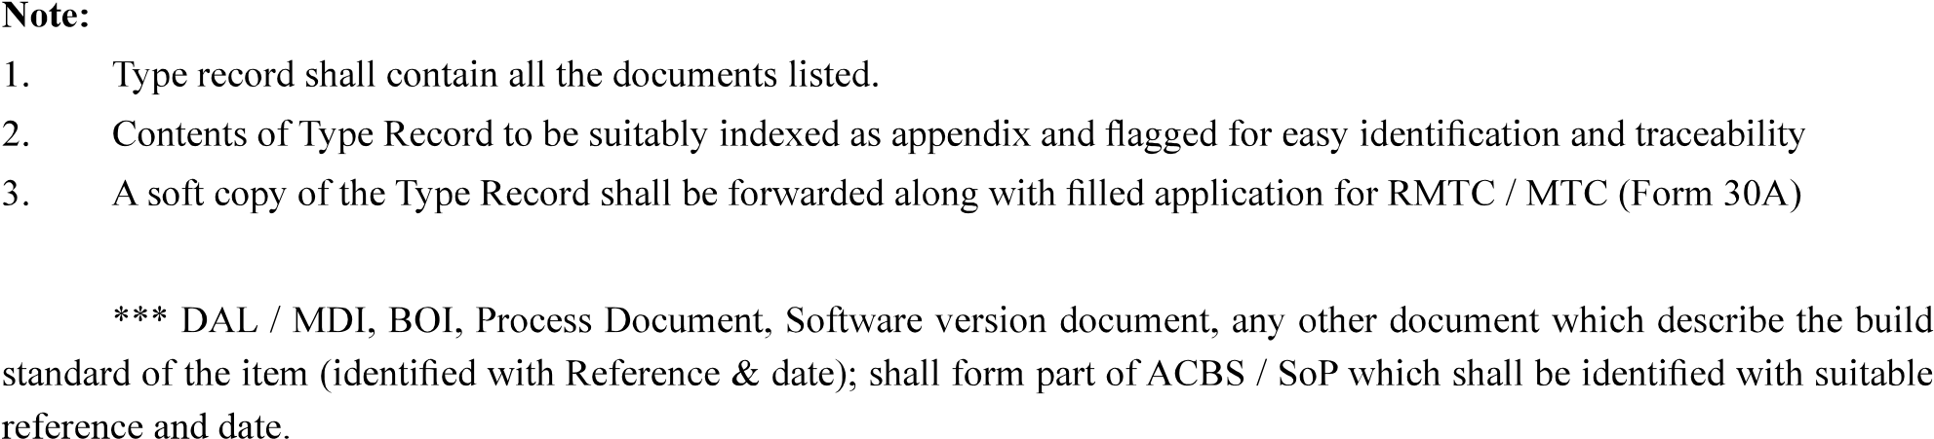

|  |  |
| --- | --- |
| Version : 2.0 | Date: August 2023 |

67