…………………………

………………………………………………………………………………………………………………………………………………………………

…………………….

………………

……………….

…...

……….

………………….

# FORM - 30B TYPE CERTIFICATE DATA SHEET

**Contents**

…………………………………..

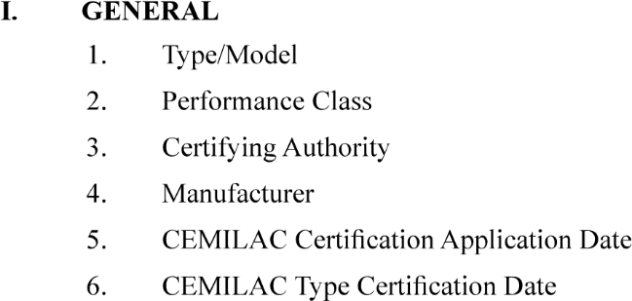

……………………………………

………………………………………

…………………………………………………………..

……………………………………………………….

……………………………………………………………

1. CERTIFICATION BASIS

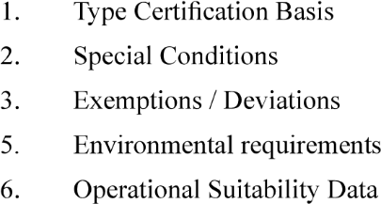 ………………………………

……………………………………………………

…………………………………….

……………………………………………………………..

………………………………………………………..

1. TECHNICAL CHARACTERISTICS AND OPERATIONAL LIMITATIONS
2. OPERATING AND SERVICE INSTRUCTIONS
3. OPERATIONAL SUITABILITY DATA (OSD)
4. CERTIFICATE OF CONFORMITY AS PER FORM NO. 52 (By the Quality Head of the Organisation duly endorsed by DGAQA as Applicable)