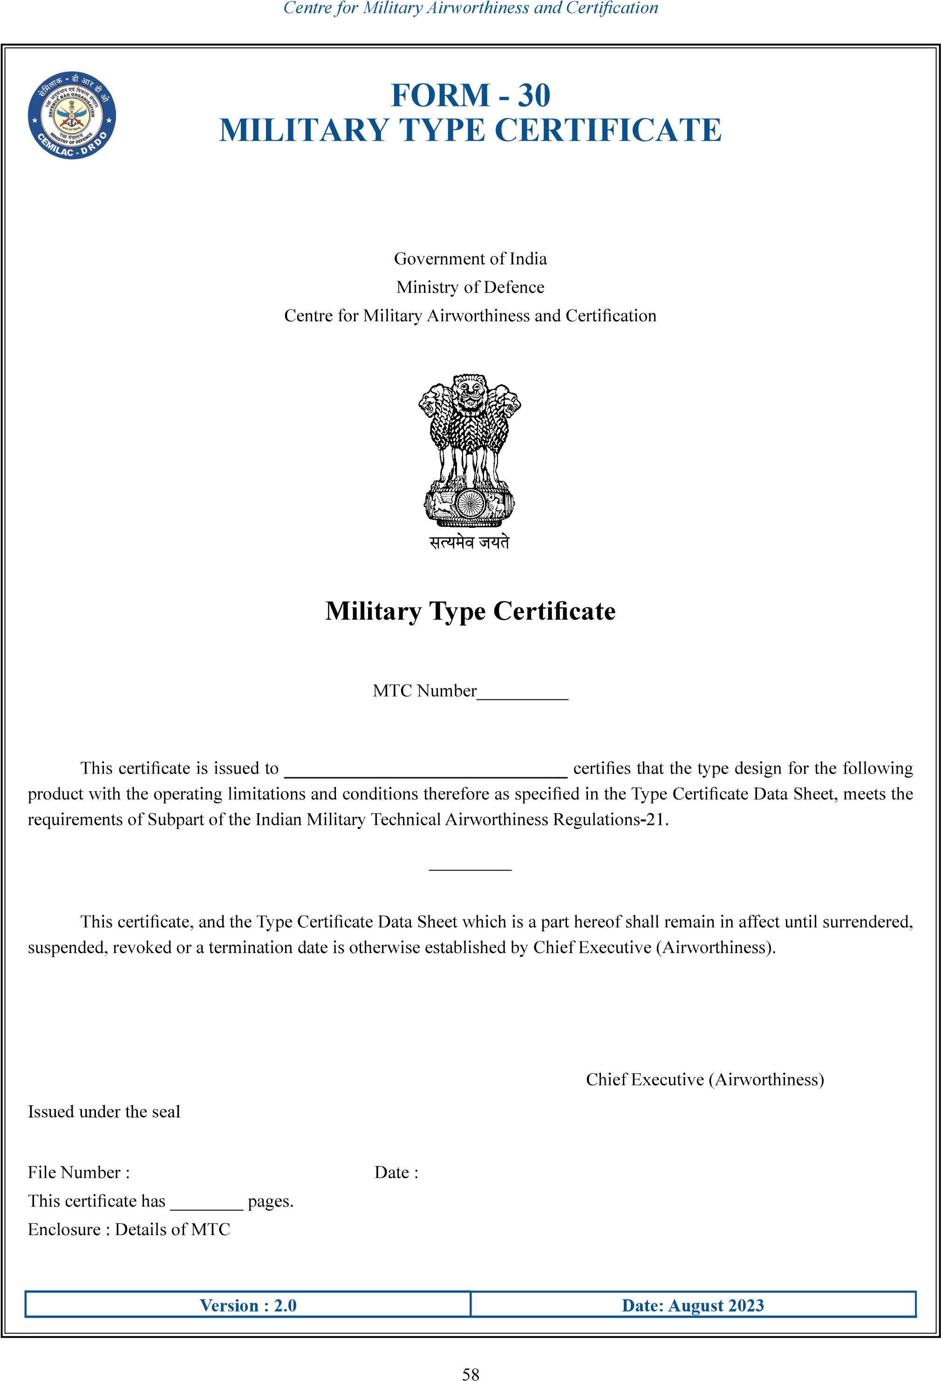

……..

….

………………….

…………………

……………………………..

………………..

……………………………………

……………

|  |  |  |  |  |  |  |  |  |  |  |  |  |  |  |  |  |  |  |  |  |  |  |  |  |  |  |  |  |  |  |  |  |  |  |  |  |  |  |  |  |  |  |  |  |  |  |  |  |  |  |  |  |  |  |  |  |  |  |  |  |  |  |  |  |  |  |  |  |  |  |  |  |  |  |  |  |  |  |  |  |
| --- | --- | --- | --- | --- | --- | --- | --- | --- | --- | --- | --- | --- | --- | --- | --- | --- | --- | --- | --- | --- | --- | --- | --- | --- | --- | --- | --- | --- | --- | --- | --- | --- | --- | --- | --- | --- | --- | --- | --- | --- | --- | --- | --- | --- | --- | --- | --- | --- | --- | --- | --- | --- | --- | --- | --- | --- | --- | --- | --- | --- | --- | --- | --- | --- | --- | --- | --- | --- | --- | --- | --- | --- | --- | --- | --- | --- | --- | --- | --- | --- |
| ……….…………………  FORM - 30  MILITARY TYPE CERTIFICATE   |  |  |  |  | | --- | --- | --- | --- | | Details of the TC Holder | | | | |  | |  | | |  | |  | | | Address | |  | | | Air System Details | | | | |  | |  | | |  | |  | | |  | |  | | |  | |  | | |  | |  | | |  | |  | | |  | |  | | |  | |  | | |  | |  | | |  | |  | | |  | |  | | |  | |  | | |  | |  | | |  | |  | | | Version : 2.0 | | Date: August 2023 | | |

59