Directorate General of Aeronautical Quality Assurance

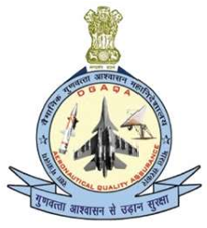FORM - 2A

APPLICATION FOR SIGNIFICANT CHANGES OR

VARIATION OF SCOPE AND TERMS OF

MAINTENANCE ORGANISATION APPROVAL

Note: This Form to be provided along with Form F1001, Appendix A of AFQMS 2018, Issue-II

|  |  |  |
| --- | --- | --- |
| DIRECTORATE GENERAL OF AERONAUTICAL QUALITY  ASSURANCE (DGAQA)  GOVERNMENT OF INDIA, MINISTRY OF DEFENCE ‘H’ BLOCK, NEW DELHI-110011 | | |
|  | |  |
| 2. Approval reference number | |  |
| are requested | |  |
|  | | |
|  | |  |
|  | |  |
|  | |  |
|  | |  |
| nominee | |  |
|  | |  |
| Version : 2.0 | Date: August 2023 | |

Directorate General of Aeronautical Quality Assurance

FORM - 2A

APPLICATION FOR SIGNIFICANT CHANGES OR

VARIATION OF SCOPE AND TERMS OF

MAINTENANCE ORGANISATION APPROVAL

Guidelines for Completion of the Form - IMTAR Form 2A

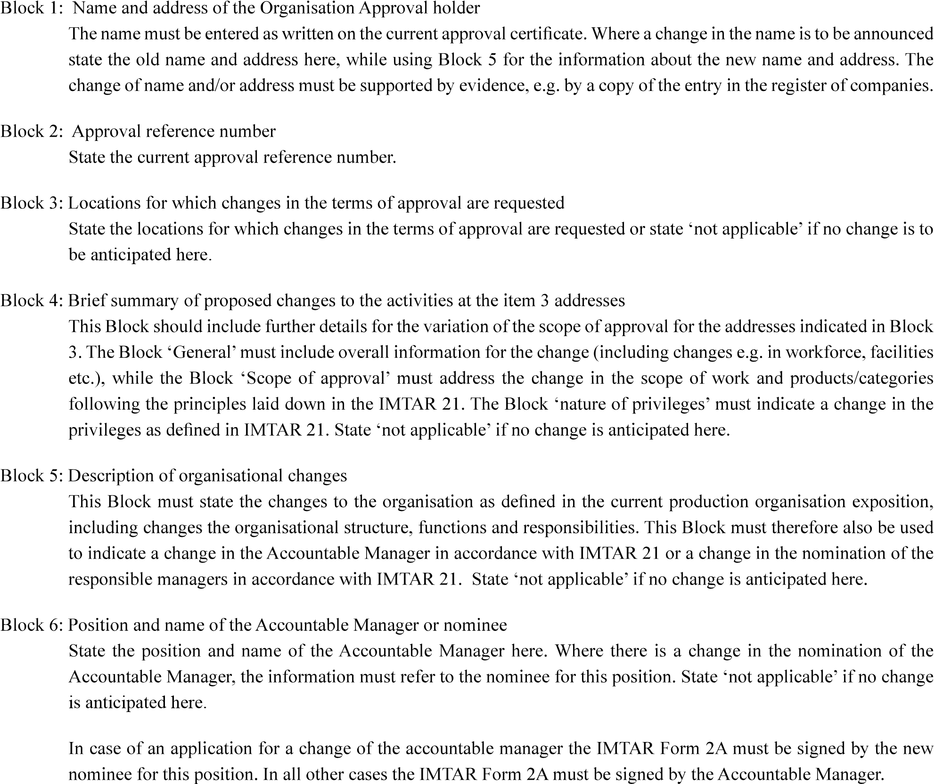

|  |  |
| --- | --- |
| Version : 2.0 | Date: August 2023 |

5