

FORM - 29C

TYPE RECORD FOR AIRBORNE STORES

|  |  |  |  |  |  |
| --- | --- | --- | --- | --- | --- |
| Sl. No. | Contents of Type Record | | Details, Reference | Record (as Appendix-A onwards with Page numbers) | |
|  |  | |  |  | |
| 2 | a Nomenclature b Part Number | |  |  | |
| 3 |  | |  |  | |
|  |  | |  |  | |
|  |  | |  |  | |
|  |  | |  |  | |
|  | c Process document | |  |  | |
|  |  | |  |  | |
|  |  | |  |  | |
| 5 |  | |  |  | |
| 6 |  | |  |  | |
| 7 |  | |  |  | |
| 8 |  | |  |  | |
| 9 |  | |  |  | |
|  |  | |  |  | |
|  |  | |  |  | |
|  |  | |  |  | |
| Version : 2.0 | | Date: August 2023 | | |

FORM - 29C

# TYPE RECORD FOR AIRBORNE STORES

|  |  |  |  |
| --- | --- | --- | --- |
|  | In case of multiple ToT same shall be indicated . |  |  |
|  |  |  |  |
|  |  |  |  |
|  | amendments issued |  |  |
|  |  |  |  |
|  |  |  |  |
|  |  |  |  |

Signature of Head of Design

Signature of the Main Contractor (If applicable) (Note 1)

Recommendations of Regional Director

(SIGNATURE OF RD WITH SEAL)

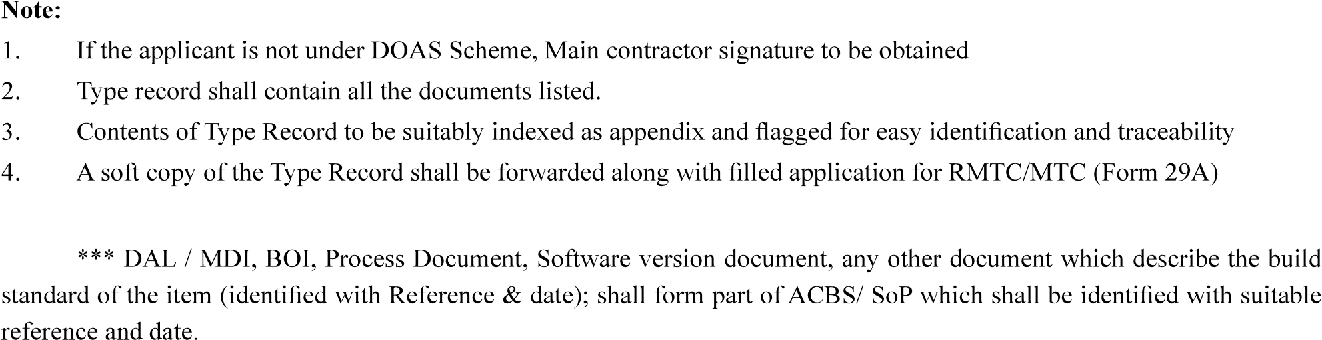

|  |  |
| --- | --- |
| Version : 2.0 | Date: August 2023 |