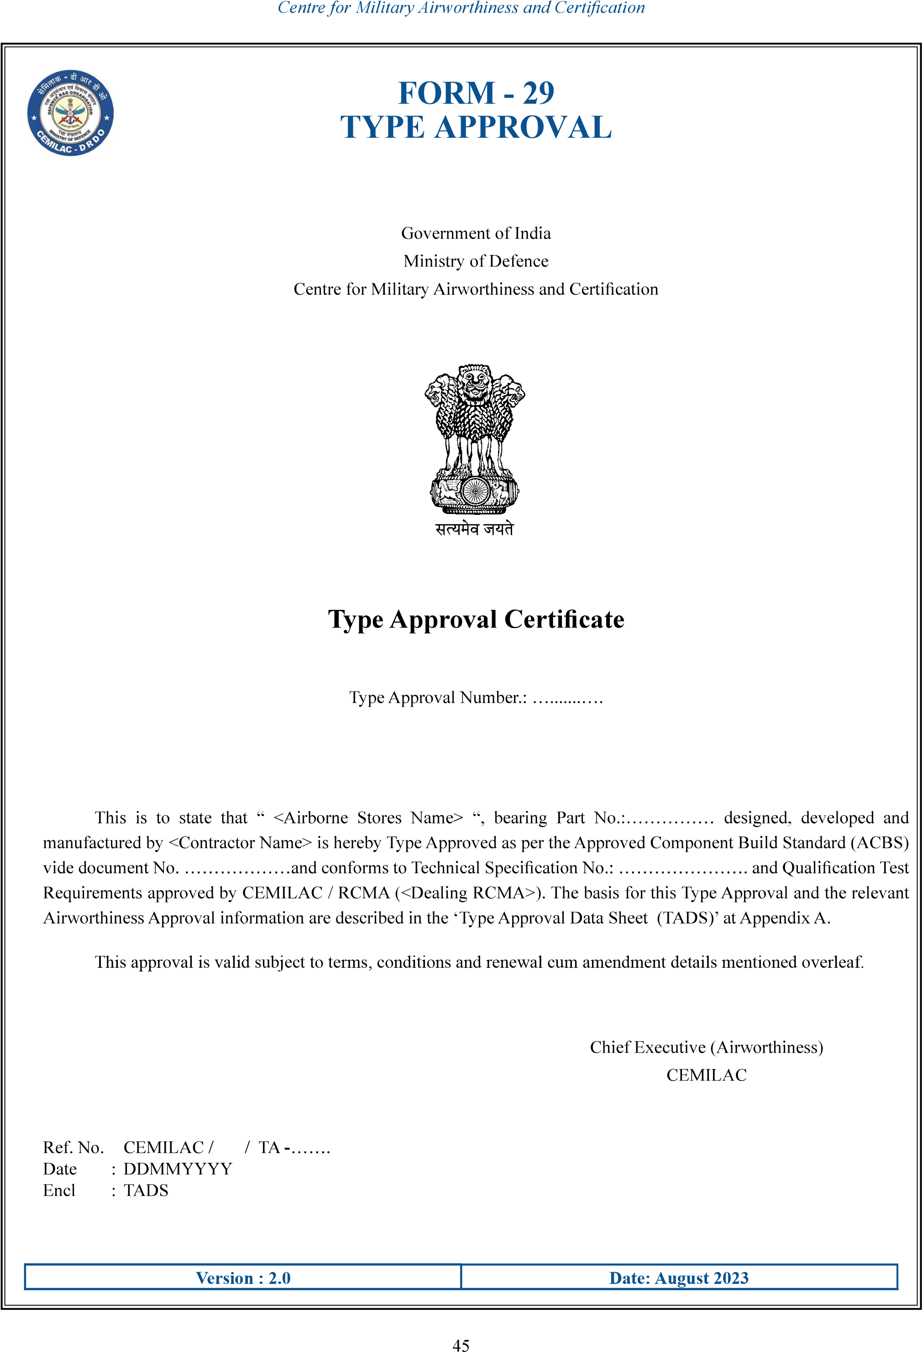

<Dealing RCMA>

………..

<Contractor name>

**Chief executive (Airworthiness)**

**CEMILAC**

......................

……………..

….……

“<Airborne stores name>”

……………………….

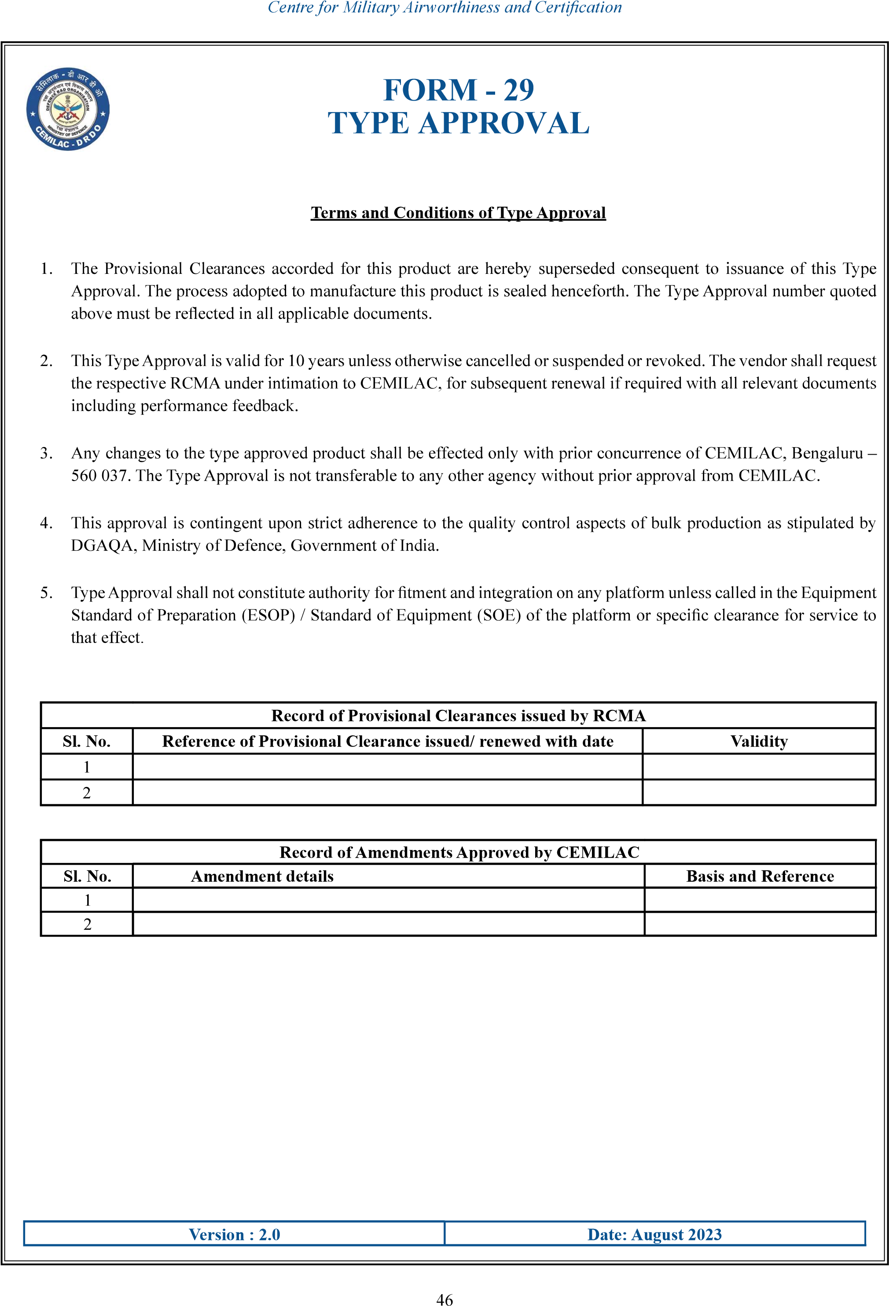

ghvjo

vjgjgj