Directorate General of Aeronautical Quality Assurance

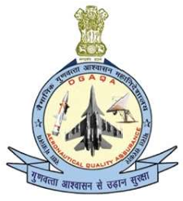

FORM - 25

SIGNALING OUT CERTIFICATE

FOR AN AIR SYSTEM

To

SIGNALING OUT AIR SYSTEM _____________ (TYPE), TAIL NUMBER (_____________)

After _______________________ (Mfg / Upgrade / Servicing / Overhaul)d

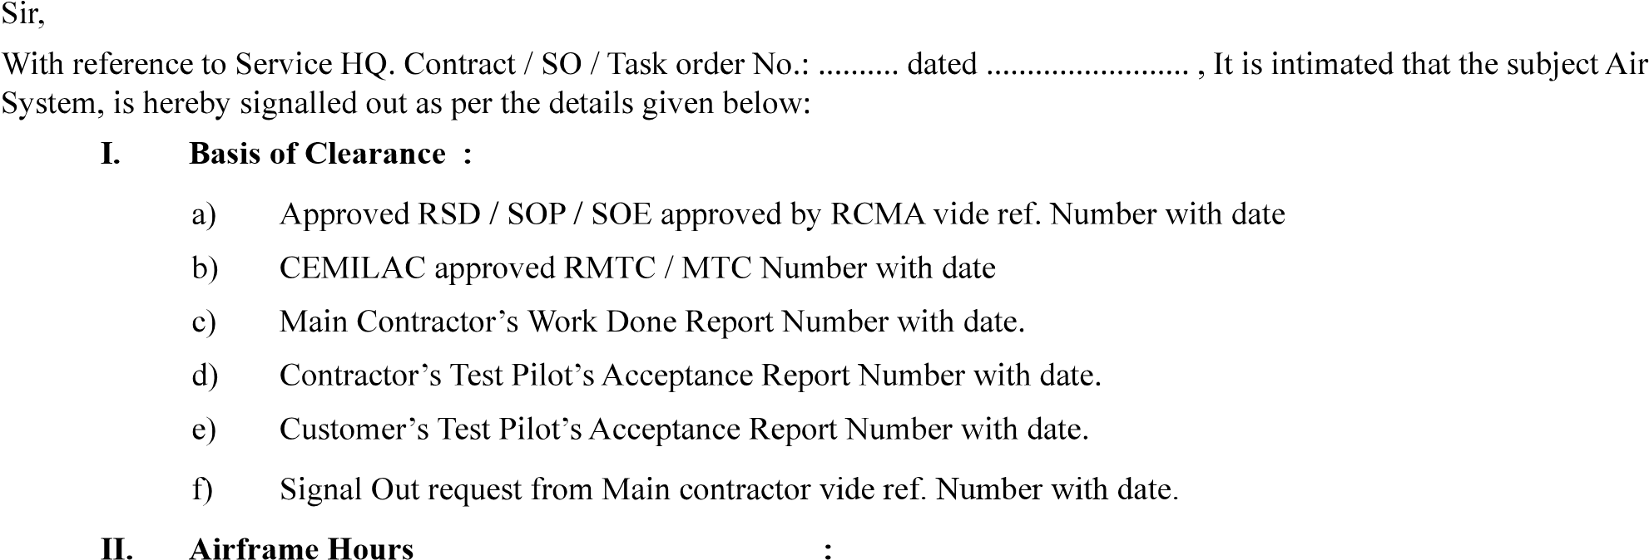

……

………………..

III. Engine Number with completed Hours :

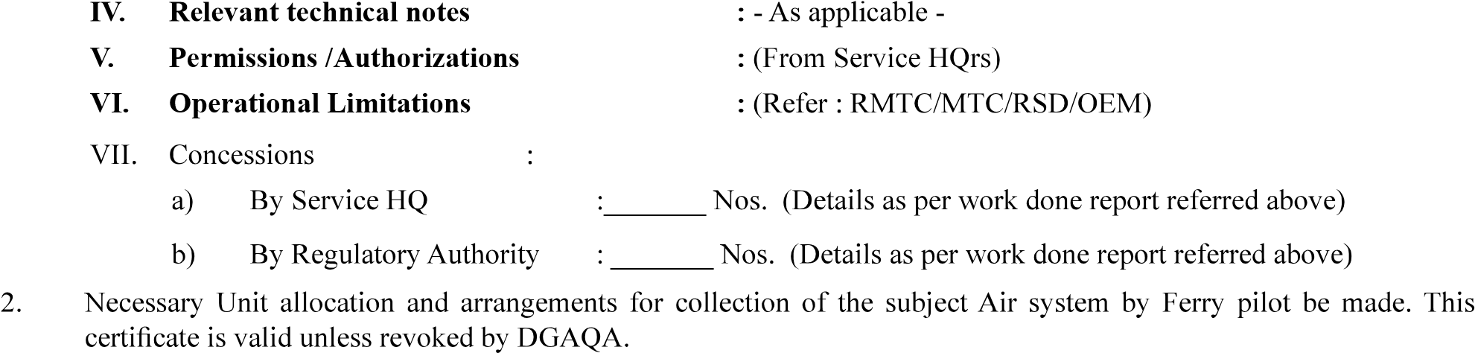VI. Operational Limitations

Distributions:

|  |  |
| --- | --- |
|  |  |
|  |  |
|  | |
|  |  |