# FORM - 21E DESIGN CRITERIA FORM/ INPUT DATA SHEET FOR NON METALLIC MATERIALS AND COMPONENTS, PAINTS AND COATINGS

Project : Material Name of Inspection Agency : Manufacturing Process Route :

Name of the Developing/ Manufacturing Agency: Supply Condition :

Nominal dimension of the component (if applicable):

|  |  |  |
| --- | --- | --- |
| Reference |  | |
| Applicant’s Reference |  | Date |

|  |  |
| --- | --- |
| Version : 2.0 | Date: August 2023 |

|  |  |  |
| --- | --- | --- |
|  | Reference No. |  |
| 2. | Nomenclature of the Product |  |
| 3. |  |  |
|  |  |  |
| 5. |  |  |
| 6. |  |  |
| 7. |  |  |
| 8. |  |  |
| 9 |  |  |

Enclosures

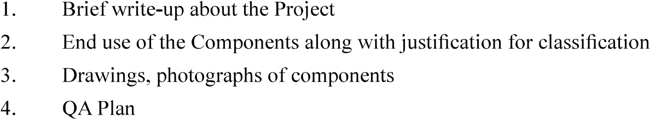

Signature

Name & Designation

Name of Organisation (with Seal)

Countersigned by CEMILAC