|  |  |  |
| --- | --- | --- |
| Reference |  | |
| Applicant’s Reference |  | Date: |

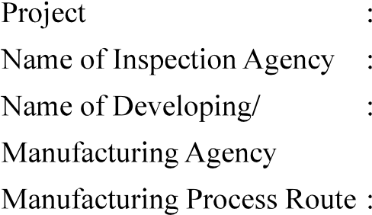

|  |  |  |  |  |  |  |  |  |  |
| --- | --- | --- | --- | --- | --- | --- | --- | --- | --- |
| No. | onent | cation |  | | | Environmental | Temperature | requirements* | information |
|  |  | conditions |
|  |  | Non  critical |  |  |  |  |  | No. of joints,  details which are to be welded, Material  approved or |  |

Enclosures:

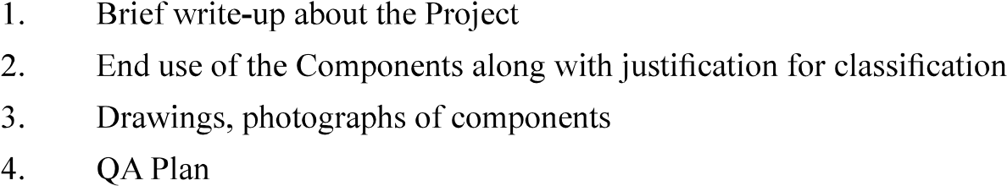

Signature:

Name and Designation:

Name of Organisation (with Seal):

Counter Signed by CEMILAC

|  |  |
| --- | --- |
| Version : 2.0 | Date: August 2023 |