Directorate General of Aeronautical Quality Assurance

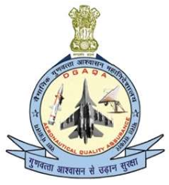

FORM - 2

APPLICATION FOR MAINTENANCE

ORGANISATION APPROVAL

Note: This Form to be provided along with Form F1001, Appendix A of AFQMS 2018, Issue-II

|  |  |  |
| --- | --- | --- |
| DIRECTORATE GENERAL OF AERONAUTICAL QUALITY  ASSURANCE (DGAQA), GOVERNMENT OF INDIA, MINISTRY OF DEFENCE, ‘H’ BLOCK, NEW DELHI-110011 | | |
|  | |  |
|  | |  |
|  | |  |
|  | | |
|  | |  |
|  | |  |
|  | |  |
|  | |  |
|  | |  |
|  | |  |
|  | |  |
|  | |  |
|  | |  |
| Version : 2.0 | Date: August 2023 | |

2

Directorate General of Aeronautical Quality Assurance

FORM - 2

# APPLICATION FOR MAINTENANCE ORGANISATION APPROVAL

Guidelines for Completion of the IMTAR Form 2

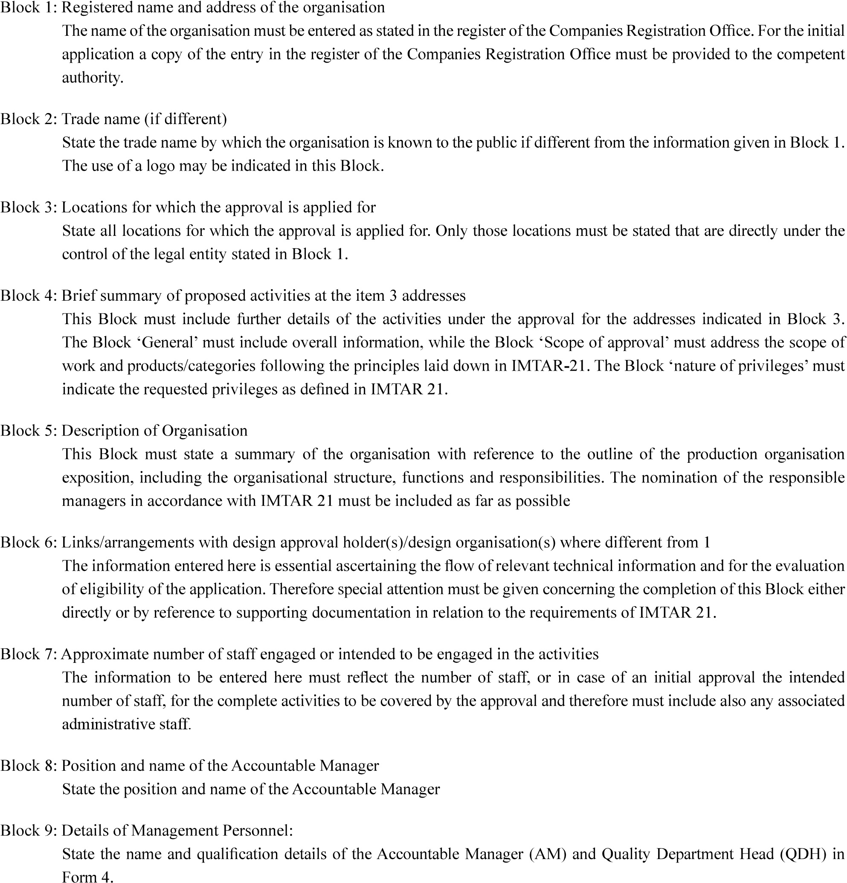

|  |  |
| --- | --- |
| Version : 2.0 | Date: August 2023 |

3