|  |  |
| --- | --- |
| Version : 2.0 | Date: August 2023 |

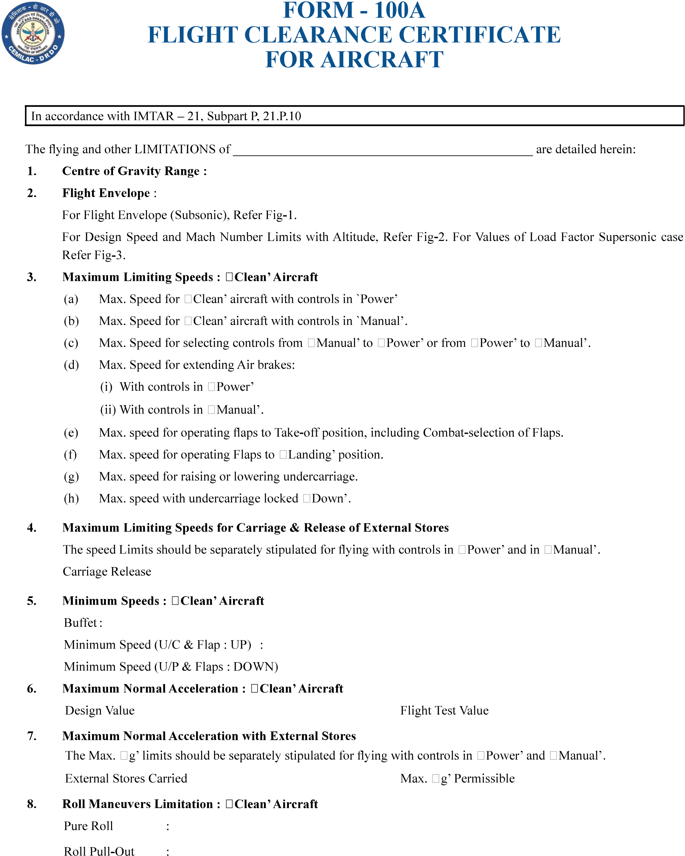

# FORM - 100A FLIGHT CLEARANCE CERTIFICATE FOR AIRCRAFT

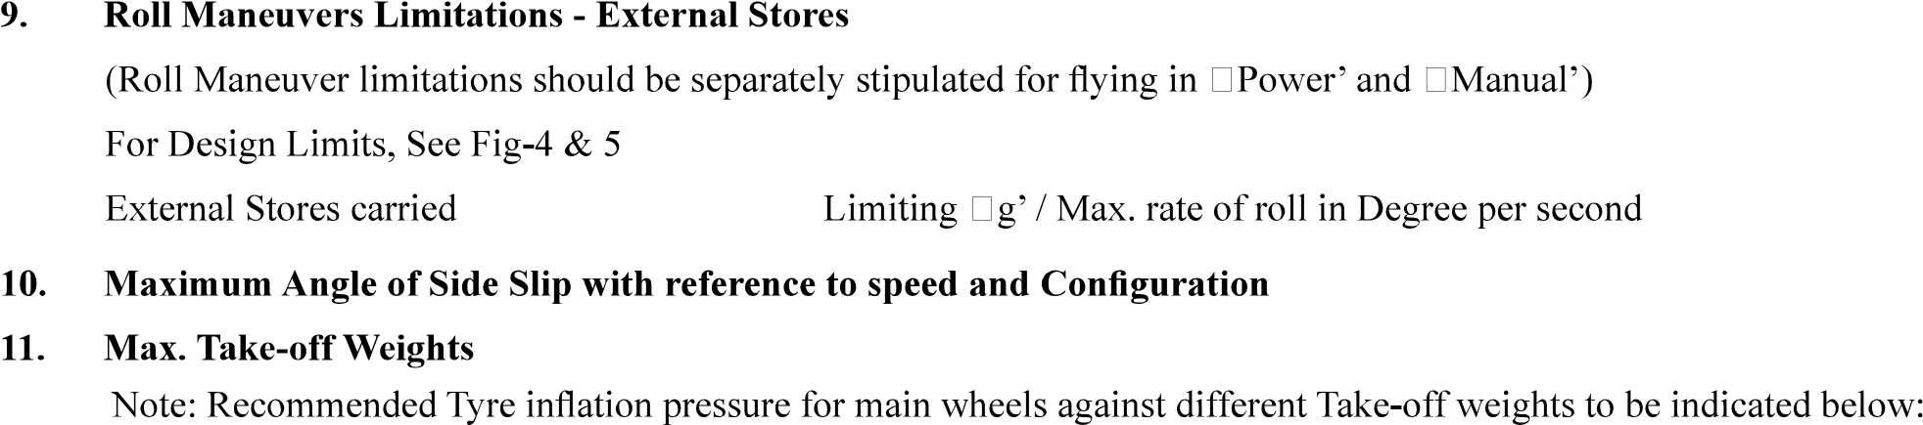

|  |  |
| --- | --- |
| Version : 2.0 | Date: August 2023 |

13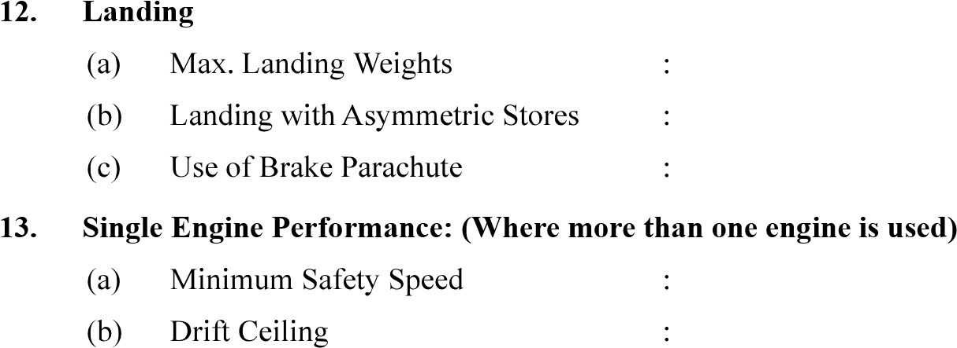.

1. One Engine Failure During Take-off : (Where more than one engine is used) (Min Safety Speed)
2. Engine Relights (Relight envelop speed / mach no. vs altitude)



1. Pressure Error Correction
2. Use of AVTAG (JP-4) Fuel
3. Gun Firing
4. Ejection Seat
5. Engine Limitations

