|  |  |
| --- | --- |
| Version : 2.0 | Date: August 2023 |

Directorate General of Aeronautical Quality Assurance

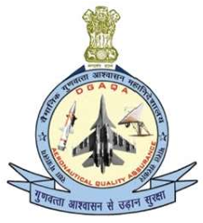

FORM - 1

AUTHORISED RELEASE NOTE

CERTIFICATE

|  |  |  |  |  |  |  |  |  |  |  |
| --- | --- | --- | --- | --- | --- | --- | --- | --- | --- | --- |
| No. | |  | | | | | | | 3. Release Note No. | |
|  | | |  | | |  | | | | |
|  |  | 9. Part |  |  | | | | | Inspector’s Inspection stamp | |
|  |  |  |  | Accepted Till date |
|  | |
|  |  |  |  |  |  |  |  |  |  |  |
|  | | | | | | | | | | |
| User / Installer Responsibilities | | | | | | | | | | |
| It is important to understand that the existence of the document alone does not automatically constitute authority to install the article on aircraft / aero-engine / System. | | | | | | | | | | |