UV Laser Induced Fluorescence LIDAR Technology for detection of Biological Warfare Agents

Technical Appreciation

Laser spectroscopy is a powerful technology for Homeland security in Defence as well environmental sciences and medical sciences. In present scenario due to increased terrorist activities, threat to military personnel and civilians appears in the form of biological, chemical warfare agents and explosives. Minimizing the impact of such threats requires early detection of the presence of these hazardous agents from a remote or standoff safe distance as well as point distance.
Biological warfare is perceived as one of the most serious threats to mankind. Bio-agents can be categorized as bacterial agents, viral agents, reckettsiae, fungi and biological toxins. Early detection and warning systems are therefore one of the most sought after gadgets for homeland security. Ultra Violet Laser induced fluorescence (UV LIF) is fast emerging as potential technique for development of such systems for standoff detection of biological warfare agents. Standoff UV LIF technique is highly capable to detect any kind of bio-agents like Anthrax Bacillus in aerosol form, from ranges up to 1.0 kilometer. Anthrax Bacillus was used as a biological weapon in year 2001 in USA. The most widely studied standoff bio-signature in UV LIF belongs to NADH and Tryptophan the two main fluorophores bio-chemical present in most of bio-warfare agents. The commonly transmitted wavelength is the fourth harmonic of Nd: YAG (266 nm).
LASTEC has developed and demonstrated Laser Induced Fluorescence based technology for the detection of Biological Warfare Agents, in the form of solid, liquid, adsorbed Surfaces, and Bio-aerosols from standoff distances of up to 1000 meters. Salient features of the technology are given below:

Salient Features:
- Detection Range : 1000 meters
- Detector: ICCD Spectrometer
- Detection Sensitivity : order of ppm
- Agents for detection: Tryptophan, and Bacillus class bacteria in aqueous solution and bio-aerosols
- Excitation source : Solid state Laser, 266nm
- Telescope : Newtonian

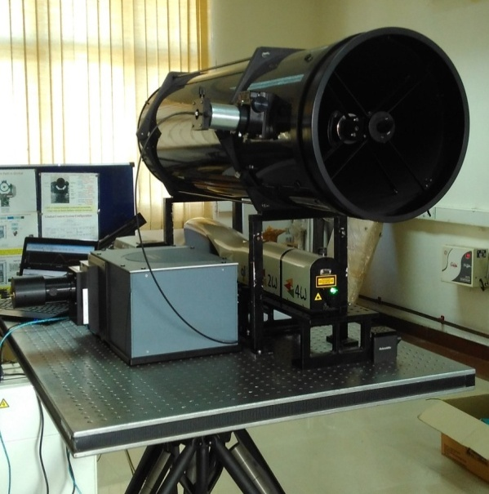

Laboratory prototype of Tripod Schematic of UV Lidar System
Mounted UV LIF LIDAR System

Important constituents of Bio-LIDAR:
1. UV Laser source
2. Telescope
3. ICCD Spectrometer and PMT detector.

