Light weight Ergonomic snow boot
Problem Identified:
Existing indigenous snow boot is heavy weight; having insufficient layer of thermal insulation at foot bed, vamp area, ankle area; no inner lining of breathable fabric, poor grip on the snow covered terrains, soft outer sole. Thus, the ergonomic needs are not fulfilled (as per the users’ requirement).
Innovative approach to solve the problem:
The newly developed snow boot is based on Ergonomic principles, which is more lightweight by virtue of integrating different materials in different sections. The invention consists of a relatively lighter rubber outer shell integrated with rigid outsole, a detachable rubber ankle support cuff-quarter, a rubber hard tongue, a leather outer box, an advanced lacing pattern with combination of D-rings and hooks. The outsole can house the crampon as per the requirement.
Potential benefits of the new invention:
- Ergonomically designed for better fit, comfort, safety and suability.
- Occupational sectors like defence, construction and safety work as well as recreational mountaineers and trekkers will be highly benefited with present invention.
- The present ergonomic snow boot weighs approx. 2.2 Kg compared to its existing counterpart with approx. weight of 5Kg.
- The entire boot is made single unit
- The outer shell of rubber is constructed upto the height of ankle joint and then a water proof leather upper box, thus contributing to the light weightiness.
- The shoe lacing with four (4) different variety of Eyelets of brass, totaling 16 numbers on both side of the boot, provide stronger fastening of the boot including the ankle support cuff.
- There is an outer hard rubber tongue at the top of soft tongue which offers enhanced protection to soft structure during vigorous movements over rough terrain.
- The foot bed is constructed with midsole of rubber sheet/PU/EVA/PP, strobel cloth, and a insole/ of light weight materials, for advanced impact shock.
- The inner layer of breathable fabric permits water vapour across the membrane and keeps the foot dry which may ultimately prevent microbial infection of the foot.
- The Ankle support Cuff quarter is attached to the shell with a flexible hinge, providing support and strength to the ankle during power step.
- The outsole of the present invention is constructed with Zic pattern and sand texture high cleats for extra slip resistance over snow covered terrain, reducing the risk of fall and injury.
- Crampon attachment facility has been provided at the outsole.
- Zipping facility has been provided for quick wear and remove of the boot during emergency.
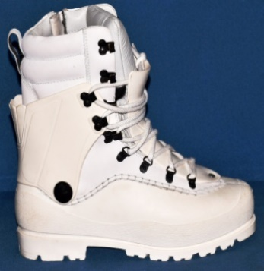
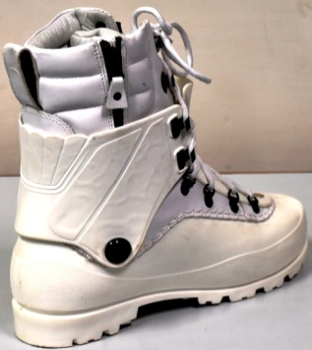
Light Weight Ergonomic Snow Boot

