MR MOUNT

- Brief technology details

Anti –vibration mounts are developed to connect two structures such a way that vibrations are controlled from reaching one structure to other. Passive rubber mounts have been widely used for vibration isolation and damping. Generally mechanical vibrations are occurring in low frequency region and they are ineffective at these frequency region. To overcome this issue, an intelligent, closed loop feedback controlled, magnetorheological fluid anti –vibration mounts are designed and developed.
The mount consists of a load bearing elastomer, MR fluid chamber, MEMS based vibration sensor and a controller for closed loop feedback control mechanism. The controller regulates the solenoid current in the MR fluid chamber, which in turn regulates the flow of MR fluid through the valve and controls the vibrations in real time.

- Uniqueness of the technology

Closed loop feedback controlled MR anti vibration mount is developed by NPOL for onboard applications. The mount can control vibrations in real time and can work both in passive and active modes. The mount is effective for low frequency damping and isolation where commercially available mounts fail to act.

- Applications area

We have developed these anti-vibration mounts for onboard applications in Naval ships and submarines. This device can be used for varieties of applications for precise motion control and energy absorption such as vibration control of laser mounting tables, gun recoiling system, vibration control of washing machines, seismic dampers, if suitably modify these principle can be extended for automobiles for real time suspensions which is not available right now in Indian market

- IP status

Since such a device is first of its kind in India, we have filed an Indian patent. The device utilizes a smart material called magnetorheological fluid which we have patented in USA, UK, France , Japan and India.

- Current status
The mount is accepted by Indian navy for onboard applications
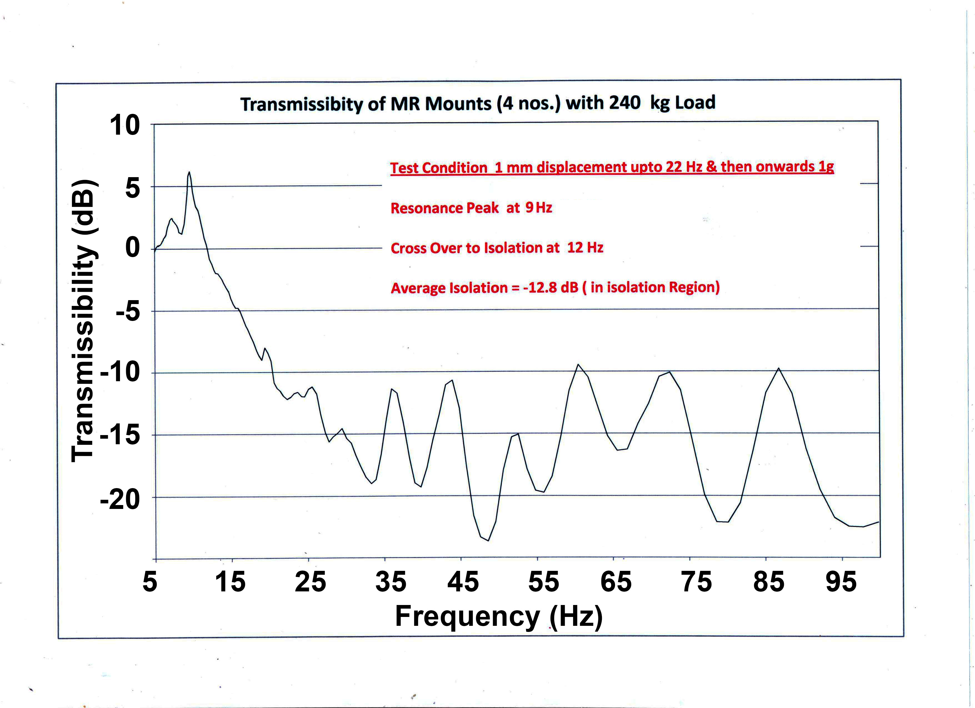
MR Mount set

