C Band Quad T/R Module (C-QTRM)

Electronics and Radar Development Establishment (LRDE), a premier lab under DRDO has developed state-of-art Radar systems and associated Technologies. LRDE is seeking Expression of Interest (EoI) from prospective bidders/recipient for Transfer of Technology in the area of Radars. Presently, LRDE is ready for ToT of the “C Band Quad T/R Module (C-QTRM)”.

- Description of Technology:
The C-Band Quad T/R Module (C-QTRM) designed and developed by LRDE is the basic building block of the Active Array Antenna Units in the C-band programs for Indian Defence Agencies.
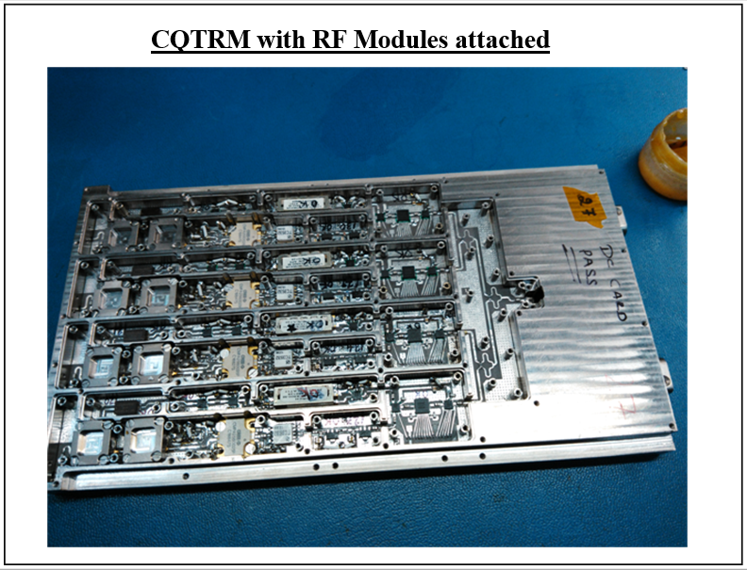
In Transmit (Tx) mode, the T/R Modules receive the RF signal, amplify it and transmit the amplified signal and fed through circulator to the antenna radiating elements. In receive (Rx) mode, each T/R Module receives a signal from antenna element through circulator and provides Low Noise Amplification of the signal after being band limited by BPF and limiter. Four numbers of T/R Modules are housed in a single package called the Quad T/R Module (QTRM). The QTRM in C-Band is called C-QTRM and is integrated with 1:4 way RF power combiners/divider. Each T/R module of C-QTRM is channelled inside with metallic walls between RF blocks in order to minimize coupling effects between adjacent T/R Module paths. The C-QTRM is controlled by a common QTRM Controller (FPGA based). The housing is made from N6061 Al metal and has finishing better than 200µm.
Fully populated C-QTRM
C-QTRMs were developed by LRDE and produced in BTS mode to cater to the requirements of Active phased arrays programs.

- Application Areas:

The C-QTRMs can be used in the area of C-band Active Phased Array Antennas for communication, meteorological and telemetry tracking radar applications.

Interested Industries may submit their company profile, financial &technical Capabilities etc. as per the EOI terms (Refer Appendix-D in ‘DRDO Policy and Procedures for Transfer of Technology’ available at web link https://drdo.gov.in/transfer-technologies) to Director, LRDE, Bengaluru and copy to Director DI²TM on the following addresses within 45 days of this advertisement.
Director, LRDE  DRDO, Min. of Defence,  C V Raman Nagar  Bengaluru-560093  Contact No : 080 - 25025415  080 - 25025518 (ToT cell)  Fax : 080 - 25242916 | Director, DIITM  Room No 446 DRDO Bhawan  DRDO HQrs Ministry of Defence  Rajaji Marg New Delhi – 110011  Contact No : (011) 23016216 / 23007446  Fax : (011) 23793008

