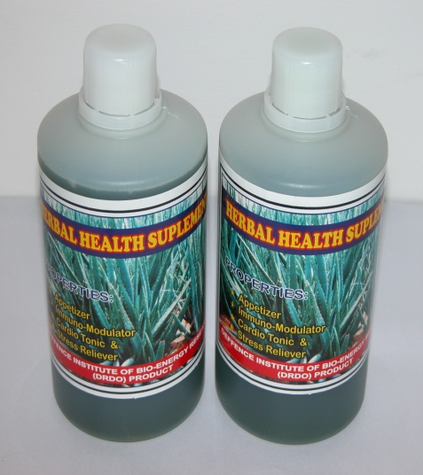
ALOE VERA HERBAL HEALTH BEVERAGE

Herbal health supplement has been formulated from Himalayan medicinal plants which are rich source of vitamins, minerals, amino acids especially essential amino acids, enzymes, glycosides, lignin, saponins, mono and polysaccharides, having antioxidants, immunomodulator, memory enhancer and appetizer properties. This herbal health supplement is very helpful in prevention of various body ailments, improving and maintaining good physical and mental health. The four medicinal plants taken in the formulation are HHS-1, HHS-2, HHS-3 and HHS-4. In this herbal health supplement primary and secondary metabolites are present in ample quantities. Among primary metabolites, the vitamin A, B₁, B₂, B₆, niacin, vit. C and Vit. D are present in very good quantity. The minerals like sodium, potassium, calcium, magnesium, copper, zinc, iron, manganese and cobalt are also present in this performance enhancer herbal formulation. It was found rich in micro elements like iron, zinc and cobalt. Water extract of HHS-2, HHS-3 and HHS-4 were used in the drink and invert sugar (mixture of glucose and fructose) is used as sweetener which also provides instant energy. In fast life of present time people having a lot of mental and physical stresses and don’t have enough time to take vegetables and fruits in a balance manner, therefore, this type of performance enhancer herbal formulations have proven their significance. By consuming a little quantity of these herbal formulation once or twice a day one can fulfill his nutritional requirements up to some extant. Apart of having rich in minerals, vitamins, protein, amino acids, carbohydrates etc. This herbal health supplement also provides medicinal advantages of HHS-1, HHS-2, HHS-3 and HHS-4. It is an extremely effective intracellular antioxidant and free radical scavenger. It has memory enhancer appetizers and cardiac tonic properties also.

Toxicological studies

The toxicological studies of this herbal formulation has been carried out at Sriram Institute, New Delhi and DIBER Fd. Stn, Pithoragarh for acute oral toxicity, sub- acute oral toxicity, sub-chronic and chronic toxicity studies. The LD₅₀ of this supplement is >2000mg/ Kg body weight. This Herbal Health Supplement free from heavy metals also and found safe for human application.

Method of Use

25 ml concentrated juice diluted with 200 ml water and taken twice a day.

