FLEXI LIFE SAVER WATER PURIFIER
Annexure F
__________________________________________________________
Aim: To provide purified water from drinking water to solider and civilian during operational movements and disasters Scenario.
Description: Defence Laboratory has developed life saver water bottle in response to requirements from services and Disaster Management Organization.
The flexi life saver water bottle is a simple to use, chemical free water purification system that removes turbidity, color, odor, microbial contamination from surface contaminated water.
It can remove turbidity from 50 NTU to less than 1 NTU and provide potable water instantly. The unit can purify a total 4000 liters under standard test conditions. It is very compact, handy and easy to handle. The Personal lifesaver bottle eliminates the need for iodine tablets, tedious boiling, chemicals, shaking, scrubbing, waiting and efforts required in conventional water purification processes.
The flexi life saver water bottle designed has the following features:
- Ideal for armed forces personnel and disaster relief operations
- Simple to operate, using any fresh water source just fill the bottle and drink.
- Removes waterborne pathogens, bacteria and viruses from water without chemicals
- Water bottle for travelling, hiking or emergency use.

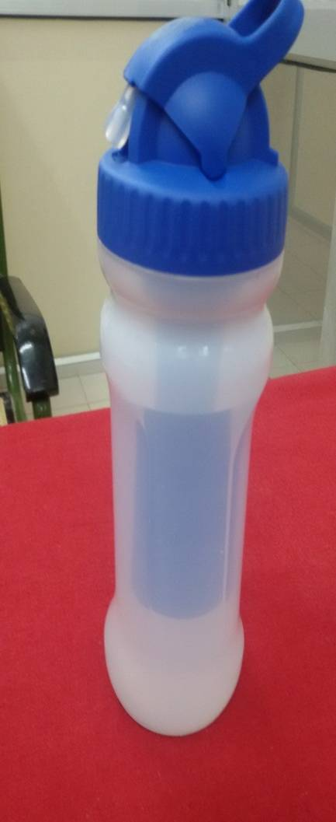
Status:
- Flexi Life Saver Water Bottle developed, 25 Nos. fabricated through industry.
- QA carried out
- ToT under process
- Requirement received:
- Army, Mechanised Bridade -450 Nos FLSWP
- BSF,NorthenFrontieres,Kashmir -05 Nos. FLSWP
5. Patent filed.
6. FLSWP given to Armoured Regiment:03Nos
- Demonstration at Northern Frontier HQ BSF

